# WEB PORTAL FOR DISTRICT COUNCIL



# 

# Session (2012-2016)

# Program

Bachelor in Computer Science (Honors)

# 

# Submitted By

Fahad Rashid 12-BCS-F-HU-13

Mudassir Ashraf 12-BCS-F-HU-14

# Supervised By

# Mr. Bilal Haider

**Teaching Assistant, IT-Department**

**HAZARA UNIVERSITY, MANSEHRA**

### FINAL APROVAL

This is to certify that we have checked the project software titled **“ Web Portal for District Council”** submitted by the following student of BCS 8th.

**Roll No. Name Registration No.**

28371 Fahad Rashid 12-BCS-F-HU-13

28419 Mudassir Ashraf 12-BCS-F-HU-14

It is our judgment that this project software is of sufficient standard to warrant its acceptance by the Department of Information Technology, Hazara University, Mansehra.

**COMMITTEE**

1. External Examiner
2. Internal Examiner
3. Supervisor
4. Head Of Department

**DEDICATION**

We dedicate our project to those respectable personalities whose prayers always give us gift of success and who encourage us in every difficult time. May, ALLAH give them happiness in both lives.

**DECLARATION**

We hereby declare that this software, neither as a whole nor as a part has been copied out from any source. It is further declared that we developed this report on the basis of our personal effort under the guidance of our project supervisor **Mr. Bilal Haider.**

We further declare that this software and all associated documents, and records are submitted as partial requirements for the degree of BS computer science.

Submitted by:

Fahad Rashid Signature:________________

Roll Number : 28371

Mudassir Ashraf Signature:________________

Roll Number : 28419

**ACKNOWLEDGMENT**

My Allah Almighty has always been the most benevolent and the most merciful and I could have never completed my task without His Blessings. So I bend my head and soul in front of my Allah Almighty in total submission and obedience. Besides that my efforts would have not succeeded without gracious and essential support of a number of individuals. The very professional and special interest, genuine guidance without snatching initiative by my supervisor, **Mr. Bilal Haider** created the most conducive environment for work. I remain indebted to his very personal involvement in the work. In addition to that whole faculty of the department of Computer Science helped creating conducive environments for the capacity building of human capital. I would not forget the ever forthcoming attitude and guidance of Sir Arif with the great name of ALLAH ALMIGHTY the most merciful. The Project was jointly undertaken by **Fahad Rashid** and **Mudassir Ashraf** as their Final Year Project, under the guidance and supervision. We are also very thankful to our Head of department **Dr. Arif Iqbal Umer** for his guideless & help. We are extremely thankful to our beloved Parents and family whose prayers and continuous encouragement made the successful completion of this project possible.

**ABSTRACT**

This current system will provide Local bodies administration to evolve over the time making their public interaction possible through online media, moreover providing provincial administration record of the work they do in their current districts. This system will eliminate the need of the paper recording schema. Public can access their representatives through this media where they can interact with them and solve these issues in less time eliminating the need of physical contacting the representative without any record of their contact with concerned representative. There are various advantages of this system which are discussed below as well the drawback of the current existing system. The primary objective of this system is to assess the adequacy of the internal control system to ensure efficient and effective operations, information security, and compliance with applicable governance.

Because of inherent limitation in the application of such controls, errors or irregularities may, nevertheless, occur and not be detected. Also, assurances regarding the adequacy of internal controls cannot be projected to future periods due to the risk that procedures may become inadequate because of changes in conditions or compliance with procedures may deteriorate.

**PROJECT IN BRIEF**

**Project Title:** Web Portal For District Council

**Submitted by:** Fahad Rashid

Mudassir Ashraf

**Supervised By:** Mr. Bilal Haider

**Starting Date:** August- 2016

**Completion Date:** October- 2016

**Software Used:**  Editor: Visual Studio 2010

Server Side Language: ASP .Net (C#)

Front End Language: HTML /CSS

JavaScript

DBMS: SQL Server

Graphics Editor: Photoshop

**System Used:**  Pentium IV, 1 GB RAM

**Operation System:** Windows 7/ 8.1 with Internet Explorer

Table of Contents

CHAPTER 1 INTODUCTION

1.1 District Council Management 1

1.1.1 Union Council Members 1

1.1.2 Sectary 2

1.1.3 Birth Record 2

1.1.4 Death Record 2

1.1.5 Disable Record 2

1.1.6 Marriage Record 3

1.1.7 School Information 3

1.1.8 School Strength 3

1.1.9 School Facilities 3

1.2 Scope of the project: 3

1.3 Objective 3

1.4 Web Application: 5

1.4.1 Centralized: 5

1.4.2 Innovate 5

1.4.3 Flexible 5

1.4.4 Data Security 5

1.5 Project Organization 6

1.6 Project Schedule 6

**CHAPTER 2 EXISTING SYSTEM**

2.1 Existing System 7

2.1.1 Manual system 7

2.2 Drawbacks of Existing System 8

2.2.1 Slow Manual Processing 8

2.2.2 Time wastage 8

2.2.3 No Particular Standard 9

2.2.4 Immense Use of Stationary 9

2.2.5 Lack of Human Resources 9

2.2.6 Inaccuracy Prospect 9

2.2.7 Data Redundancy 10

2.2.8 Security 10

2.2.9 Difficult Procedure for Information Access 10

2.2.10 Report Preparation 10

2.2.11 Manual Editing 10

2.2.12 Delay in Retrieval of Information 10

2.2.13 Delay in Data Updating 11

2.2.14 Lack of Backup System 11

2.2.15 Lack of Modern Software 11

2.2.16 Inconsistency of Data 11

2.2.17 Difficult to Use 11

2.2.18 Inflexible Data 11

2.2.19 Difficult to Modify 12

2.2.20 Lack of Standard 12

2.3 Conclusions 12

**CHAPTER 3 PROPOSED SYSTEM**

3.1 PROPOSED SYSTEM 13

3.2 Purpose of This Document 13

3.3 System Proposal 13

3.4 Features of the Proposed System 14

3.3.1 Security 14

3.3.2 User-Friendly 14

3.3.3 Less Time-Consuming 14

3.3.4 Error Free 14

3.3.5 Accuracy 14

3.3.6 Usability 14

3.3.7 Conciseness 15

3.3.8 Efficiency 15

3.3.9 Queries and viewing facility 15

3.3.10 Editing function 15

3.3.11 Understandability 15

3.5 Problems Addressed By The Solution 16

3.6 Advantages of the Proposed System 17

3.7 System Architecture 17

3.7.1 User Interface 18

3.7.2 User of the System 18

3.7.3 Application Program 18

3.7.4 Backend Database 18

3.8 Feasibility Report 18

3.8.1 Operational Feasibility 18

3.8.2 Technical Feasibility 18

3.9 System application 18

3.10 Conclusion 19

**CHAPTER 4 SYSTEM DESIGN**

4.1 System Design 20

4.2 Developing a logical data model 20

4.3 ER (Entity-Relationship) diagram 20

4.3.1 One-to-one (1:1). 21

4.3.2 One-to-many (1: M). 21

4.3.3 Many-to-many (M: N). 21

4.3.4 Relationship 21

4.3.5 Binary Relationship and Cardinality 21

4.3.5.1 One-to-one 22

4.4 Choosing a development tool 22

4.5 Implementing the functionality in stages 22

4.6 Using a configuration management tool 22

4.7 Database management System (DBMS) 23

4.7.1 Conceptual Data Model 23

4.7.2 Logical Data Model 23

4.7.3 Physical Data Model 23

4.8 Conceptual ERD Symbols 24

4.8.1 Entities 24

4.8.2 Relationships 25

4.8.3 Attributes 25

4.8.4 Physical ERD Symbols 25

4.8.5 ERD Notation 26

4.9 Database Management System Models 26

4.9.2 Hierarchical 27

4.9.3 Relational 27

4.9.4 Object Oriented 28

4.10 Data base Design: 28

4.11 Data Flow Diagram: 29

4.12 Physical Design 32

4.13 Input Design 32

4.14 Data Dictionary 34

4.15 Entity with Attribute 42

4.17 Database Diagram 50

**CHAPTER 5 CODING**

5.1 Connection String 51

5.2 Login 51

5.3 Add Record 53

5.4 Edit Record 55

5.4.1 Delete Record 56

5.5 View Record 57

5.6 View Detail 58

5.7 Reading Foreign Key 59

**CHAPTER 6 TESTING**

6.1 Testing Strategies 60

6.1.2 System Testing 60

6.1.3 Test Cases 61

6.1.4 Computer Program Testing 66

6.1.5 Code Testing 66

6.2 Software Testing Report 67

6.2.1 Data 67

6.2.2 Procedures and Functions 68

6.2.3 GUI Interface 68

6.4 Implementation Testing 68

**CHAPTER 7 USER MANUAL**

7.1 Home Screen 69

7.2 Login 70

7.3 Add Application 71

7.4 Add Birth Record 72

7.5 Add Death Record 73

7.6 Add School Information 74

7.8 View School Information Detail 76

7.10 View Sectary Information 78

7.11 Sectary Detail 79

7.12 Change Sectary Password 80

7.13 Member Login 81

References 82

**List of Figure**

Figure 1.1 Project Schedule 6

Figure 4.1 Entity Symbol 24

Figure 4.2 Relationship Symbol 25

Figure 4.3 Attribute Symbol 25

Figure 4.4 Cardinality Symbol 26

Figure 4.5 Hierarchical Model 27

Figure 4.6 DFD Symbol 30

Figure 4.7 DFD Level 0 30

Figure 4.8 DFD Level 1 31

Figure 4.9 DFD Level 2 31

Figure 4.10 Admin Login 42

Figure 4.11 Application Water 42

Figure 4.12 Birth Record 43

Figure 4.13 Death Record 43

Figure 4.14 Disable Record 44

Figure 4.15 In Fund 44

Figure 4.16 Out Fund 45

Figure 4.17 Marriage Record 45

Figure 4.18 Poor Record 46

Figure 4.19 School Information 46

Figure 4.20 School PTC 47

Figure 4.21 School Strength 47

Figure 4.22 School Facilities 48

Figure 4.23 Sectary 48

Figure 4.24 Tehsil 49

Figure 4.25 Village 49

Figure 4.26 Village Council 49

Figure 4.27 Database Diagram 50

Figure 5.1 Admin Login 51

Figure 5.2 Add Record 53

Figure 5.3 Edit Record 55

Figure 5.4 View Record 57

Figure 5.5 View Detail 58

Figure 7.1 Home Screen 69

Figure 7.2 Login 70

Figure 7.3 Add Application 71

Figure 7.4 Add Birth Record 72

Figure 7.5 Add Death Record 73

Figure 7.6 School Information 74

Figure 7.7 View Teacher Information 75

Figure 7.8 View School Information Detail 76

Figure 7.9 Add Sectary 77

Figure 7.10 View Sectary Information 78

Figure 7.11 Sectary Detail 79

Figure 7.12 Change Sectary Password 80

Figure 7.13 Member Login 81

**LIST OF TABLES**

Table 1.1 Project Concerned Task 6

Table 4.1 Relational Model 27

Table 4.2 Admin Login 34

Table 4.3 Application Water 34

Table 4.4 Disable Record 34

Table 4.5 Birth Record 35

Table 4.6 Death Record 35

Table 4.7 District 36

Table 4.8 In fund 36

Table 4.9 Out fund 36

Table 4.10 Poor Record 36

Table 4.11 Marriage Record 37

Table 4.12 School Information 38

Table 4.13 School PTC 38

Table 4.14 Tehsil 38

Table 4.15 School Strength 39

Table 4.16 School Facilities 39

Table 4.17 Sectary 40

Table 4.18 Village 40

Table 4.19 Village Council 41

Table 4.20Member 41

## 1.1 District Council Management

Union council in Pakistan is an elected local government body consisting of 21 councilors (According to population), and headed by a nazim now called Chairman (which is equivalent to a mayor) and a naib nazim now called Vice Chairman (deputy). Union councils are the fifth tier of government in Pakistan and are often known as Village Councils in Khyber Pakhtunkhwa. A village council usually comprises a large village and surrounding areas, often including nearby small villages. Beside elected members, there are several government employees and functionaries in every union council, who report to the secretary of the union council. The latter is a civil servant appointed by the state.

The territory of a union council or village council is usually part of a tehsil (a district subdivision). Less commonly, a union council may be part of a city district.

The honorable Chief Minister, Khyber Pakhtunkhwa, has directed Secretary LGE&RDD to issue orders to all Deputy Commissioners in Khyber Pakhtunkhwa to complete the process of recruitment of staff in village/neighborhood councils in light of Provincial Inspection Team (PIT) enquiry report as early as possible under the Provincial recruitment policy as mentioned in the ESTA Code Khyber Pakhtunkhwa.

District Council has further village council and member village council whom are elected by public.

### 1.1.1 Union Council Members

Candidates securing highest and second highest number of votes in the election to the general seats of the village council or the [neighborhood council](http://lgkp.gov.pk/neighbourhood-council/) shall respectively be elected as the Nazim now called chairman and Naib Nazim now called naib nazim of the village council

* Five to ten members, determined on the basis of population, elected to general seats
* Two members elected to seats reserved for women
* One member elected to seat reserved for peasants and workers
* One member elected to seat reserved for youth
* One member elected to seat reserved for non-Muslims

### 1.1.2 Sectary

The Secretary, under the supervision of the Nazim shall coordinate and facilitate in community development, functioning of the Committees and delivery of such municipal services as provided in the Act**.** Sectary plays vital role he maintains all the records like applications of water and records like birth record, death record, disable record, marriage record.

Secretary has record of all the funds in union council how much amount received for development in village council and for which purposes the fund was given. Secretary has all the record of out fund how much expenditure in union council.

Also another role of sectary in union council is that he has all the information about schools in village council like information about the school, school PTC, school strength, school facilities, its secretary responsibility to conduct all the information about schools in village council how many schools and the strength of students in school how many male student and how many female students.

Another major role of secretary is to have all the information about school facilities that how much rooms in school and is there electricity facility in the school also is there water facility available in school and other things boundary wall, teacher washroom student washrooms are available or not in school.

### 1.1.3 Birth Record

A birth certificate is a vital record that documents the birth of a child. Birth record contain the information about the child, name, gender, date of birth, father NIC, mother NIC, address and village council in which the child birth.

### 1.1.4 Death Record

Record about the death of some person is contain the following information date of birth of that person, date of death, name and NIC, religion, father name mother name.

### 1.1.5 Disable Record

Disable record contain the record of disables persons and all the information regarding with them like disable person name, NIC, date of birth, contact number and what type of disability they have and village council name.

### 1.1.6 Marriage Record

The marriage record is very essential record it contain the information about the name of bridegroom, NIC number, father name, mother name, age and also age at time of marriage, status either he is single or he is married before and other relevant information about hi bridegroom is his address and the name of district, tehsil where he lives.

Also the information about bride, name NIC, father name and NIC number of father, age at the time of marriage and address of bride where she live also the amount of mehr and the detail of mehr all these information relevant information is in marriage record.

### 1.1.7 School Information

All the information about schools in village council the school name, village where is the school and who is the headmaster of school and the code of school, contact number of the school all these relevant information is kept in school information.

### 1.1.8 School Strength

Information about the students in the school, School name, classes in the school, how many male student and female student in the class and how many total students in the school and the name of class teacher. All these information is kept in the school information record.

### 1.1.9 School Facilities

School facilities contain the information about the facilities in the schools that how many rooms in the school and other facilities like electricity water, boundary wall, teacher washrooms and student washrooms are available in school or not.

## 1.2 Scope of the project:

The aim of proposed system has developed a system for improved facilities. The proposed system will overcome all the limitations of the existing system district council management system. The system provides a proper security and also reduced the manual work.

## 1.3 Objective

The proposed **web portal for district council** covers almost all of the lacks of existing system. The system provides no of advantages some key features are listed as follows:

* Improve the speed of the operation of the system.
* It resolves typical issues of manual examination processes and activities.
* To maintain accurate and complete record concerning to Schools
* To maintain accurate and complete record of Funds.
* To maintain accurate and complete record water Applications.
* To maintain accurate and complete record of secretary.
* To maintain accurate and complete record of (birth, death, disable, marriage).
* To save valuable data.
* Easy to understand and retrieve data.
* To enter data in organized form.
* To eliminate data redundancy so that there are no repeating values.
* It provides facilities to Admin that he/she adds and updates his profile.
* To provide searching facility to Users.
* Provides 24/ 7 services to user
* Always up-to-date.
* Reliable
* Easy to Use
* Easy to Update

## 1.4 Web Application:

Web applications (or web apps) are programs on the internet that can be accessed in web browsers (Firefox, Chrome, Safari, IE, etc.). These programs can provide any kind of functionality that you need to help your business or organization run more smoothly. Some examples of web apps are product catalogs, search engines, project management tools, web mail, and the list goes on and on.

This feature brings accessibility to a great number of remote users.

### 1.4.1 Centralized:

Online web based system provides cost effective solution by reducing hardware, software, technological infrastructure, personnel cost associated with a decentralized solution. This decrease the amount of time, efforts, and personnel required as well as support/maintenance cost.

### 1.4.2 Innovate

Online system provides a full featured, multimedia rich, organizational based system that can be easily integrated with your existing administrative system as we develop web portal for district council.

### 1.4.3 Flexible

Online system can be stored on web server user can easily access web site using URL. Modification can perform easily on web application.

### 1.4.4 Data Security

Built in security modules provide controlled over data access to admin by assigning a unique user name and password.

## 1.5 Project Organization

The project plan for “**Web Portal for District Council**” is as under.

Our team consists of 2 members. The communication and co-ordination issue will be solved by informal interpersonal procedure.

|  |  |
| --- | --- |
| **Members** | **Most Concerned tasks** |
| Fahad Rashid  Mudassir Ashraf | Requirement Analysis  Design , Coding , Testing |

Table 1.1 Project Concerned Task

We use combined effort while developing this system by using informal procedure

## 1.6 Project Schedule

### 

Figure No: 1.1 Project Schedule

## 2.1 Existing System

The current system at district management is manual mostly using paper work for the purpose of record keeping and public interaction. This system involves the secretaries and the public representatives to manually write their work reports about the public interaction and the public work they do. This current system is bulky and creates a lot of havoc for the administration. The study of existing system limitation and flaws is very important as will help improve the current online system in this regard. The current system has no possible means of recording the public representatives and public dealing. Therefore the provincial management has no means check the progress of their representatives.

### 2.1.1 Manual system

In many situations manual system is inferior to computerized system. The manual system is dull and it is more error prone. Manual system is to use a simple, paper-based record keeping system. Manual system is less expensive to set up. Correcting entries may be easier with manual systems, as opposed to computerized ones that can leave complicated audit trails. The risk of corrupted data is much less. Data loss is less of a risk, particularly if records are stored in a fire-proof environment. Problems with duplicate copies of the same records are generally avoided. The process is simplified as you don't need to be familiar with how accounting software calculates and treats your information. But we need to Streamline our manual record keeping, Sort and store all paperwork in 12 separate months with all original documents and date of all correspondence. We can handle our work much efficiently with the computerized system and it helps to save our time and money. The popularity of the computerized system is increasing day by day and most of systems are being computerized nowadays. The term 'online system' is commonly used to refer the system of computer and internet and the online system has played a vital role to make our lives comfortable and convenience. Now, you can buy your movie ticket online, you can share your knowledge and get whatever information you want through the internet, and you needn't go to several offices to pay your monthly utilities bill. These all are possible due to the advancement in the computer and internet technology. When people need to do the same job repeatedly then they usually make mistake, which causes the problem in information representation. The computerized system avoids such error and makes the life easier. Our lives will be really green when everything is done through computer and there is no paper work.

## 2.2 Drawbacks of Existing System

Manual system is quite inexpensive at lower volume but as for such a District Council with huge amount of data, the following drawbacks are to be encountered Following are the drawbacks that are presented in existing system, which provide a justification in replacing the existing system.

* Manually work has to be done. It will take much time for its data processing activities.
* The chances of error are frequent and can’t be avoided.
* All the information and data are being stored in the paper files and registers which are liable to destruction or loss.
* The system is not secure.
* The system is not efficient.
* Can’t handle a single person, so every day new problems are faced.
* Lack of standard procedure for data retrieval.

### 2.2.1 Slow Manual Processing

It is difficult to access and retrieve the records quickly because the data is scattered in different files and to search out the specific information or record from these files is a complicated process and the basic milestone for delayed information in the laziness of the system, that delay in information causes time wastage and sometime great loss.

### 2.2.2 Time wastage

The most important factor for measuring the efficiency of any system is time. The hectic searching for finding the records are the basic reason for the wastage of time because all the records are stored in different files and searching from them is an ambiguous process. Saving of records consumes many working hours and costs heavily. So manual system also takes much time to maintain, select and prepare the record file, which badly effects efficiency of the system.

### 2.2.3 No Particular Standard

The existing system is utilizing the manual storage media to keep the records of data that is not efficient and will not full fill the need of organization, as well as inaccurate way and is not up to the standards of the present age of science and technology and it becomes very difficult to maintain standards in the records. A lot of information needs to be mentioned in different files and the chances of error increases in the process.

### 2.2.4 Immense Use of Stationary

In any non-computerized system, the excess use of stationary is one of the major drawbacks. The existing system is utilizing all the manual techniques for the storage of information. As a result a big room is reserved for storing files. Thus, existing system is not satisfactory and become costly for the Department. In some circumstances the papers are also not reliable and long lasting to keep record on long terms.

### 2.2.5 Lack of Human Resources

All of the work in existing system is carried out manually and a large number of people are required to handle the system but due to limited resources only staff members are currently dealing with all the files for data entry and retrieval. Otherwise, some of the other staff has to dedicate there working hours towards this, which costs much and some flaws occur because of no familiarity with the working. It also costs the department in sense of working hour’s cost**.**

### 2.2.6 Inaccuracy Prospect

Because the current system cannot enforce data validation in a meaning full manner, because the data is needed to be entered in different files according to the requirements employee often enters and store data inaccurately, so the data can be inaccurate and can cause damage.

### 2.2.7 Data Redundancy

While analyzing current system, it has been found that the current system has an excessive amount of data redundancy. It is exhibited by the common set of records across several manually kept files, which not only wastes the time but also the stationary.

2.2.8 Security  
Data is also very important and sensitive assets for district council therefore, it is very necessary to protect or secure that data but the existing system lack this important fact. Data and information of existing system is not safe.

### 2.2.9 Difficult Procedure for Information Access

In existing form of the system, it is very difficult to access information quickly. If we want to know the changes in some fields or new entry of a record, then it takes considerable amount of time because of the manual search.

### 2.2.10 Report Preparation

Many types of reports are required like student record, teachers information, performance analysis but if we create these reports manually, then we have spent much more time, energy, stationary and finance.

### 2.2.11 Manual Editing

The editing procedure in the manual system is done using pen, paper and computer which look awkward and it is also difficult to make certain changes in it.

### 2.2.12 Delay in Retrieval of Information

Retrieval of required information /query takes too much time. No standardized program for data handling is present for users. Most of the time has to use different programs for generation /retrieval of information/reports

### 2.2.13 Delay in Data Updating

As there is no proper system exists for records/data files updating, data can’t be maintain timely. No proper way of issue of data is adopted. Computer operators take a little time every day for updating the records.

### 2.2.14 Lack of Backup System

No data backup system is use at present. It is possible that data may be lost due to some damage to the equipment or by power failure. No power supply backup (UPS) support the system.

Hence in case, if original equipment is damaged the retrieval of data is impossible.

### 2.2.15 Lack of Modern Software

Computer professionals cannot work in a smooth way, as no specific program is present to fulfill the all objectives. No proper system of input formats for updating.

Conventional files system is being used for maintenance of data files, but without any standardized modules for input/output.

### 2.2.16 Inconsistency of Data

The increasing volume of data can creates the problems in the existing system. As present system will be unable to handle such an enormous volume of data, it will ultimately lead to the physical death of the existing system

### 2.2.17 Difficult to Use

The existing system is cumbersome and difficult to use because the bulk of data maintained in hardcopy files.

### 2.2.18 Inflexible Data

Data stored in the current system in such a way that it is not in a very useful form and thus cannot be used in many different ways easily.

### 2.2.19 Difficult to Modify

The data stored in any file can be required to be modified at any time, but in manual system, the data cannot be easily modified. E.g. if Hotel user wants to update his/her profile it is not possible in manual system.

### 2.2.20 Lack of Standard

Current system does not define any standards for working with data. The same column in one register with the same meaning has another name in another register. This creates confusion and can also lead to inconsistency.

## 2.3 Conclusions

The above facts show the inefficiency of the existing information system & let’s to work on the direction of improvements needed for the system. Finally we conclude that there must be system which could be based on the following considerations.

* A system is required so that the data accumulation for information generation could not be delayed.
* The authorized members could access the system.
* System must be designed properly to handle all types of addition, deletion and editing.
* A standard database is required to reduce wastage of storage
* Must have characteristics of efficient and quick retrieval of the data/information
* Refresher courses must be arranged to familiarize the user and operators with the new developments and modern ideas in the field. This practice must continue for better and effective results.

## 3.1 PROPOSED SYSTEM

Computerization of the system involves the study of existing system along with all of its weaknesses and drawbacks, and then suggesting a suitable computer based system. After analyzing the existing system and finding its shortcomings, it is necessary to eliminate its deficiencies in order to define the objectives and design of the proposed system. The new system has brought some changes in the existing system but mostly the structure and numbers of fields and data codes are same as in the traditional system. Because, the little information that must be stored e.g. But some changes have been made to make system more efficient and some modifications are based on new requirements.

## 3.2 Purpose of This Document

This document will capture all the needs and requirements present in the existing annual system Institute and also the solution and constraints. Before working on the project we should clearly define the scope of project, which facilitates the working because in this way we can bind efficient and simple work within the defined boundaries.

## 3.3 System Proposal

The proposed system is specifically designed to overcome all the drawbacks of previous manual system. Pre-existing manual system faced a lot of problems, which are as follows:

* The manual system is inefficient and not user-friendly.
* It is time-consuming for the top-level management to make an effective decision.
* Less accuracy of the data is caused by manual system.
* Modification of data or updating is tedious and time-consuming job.
* Security is required which can’t be gained through the manual system.
* Stationary is required to store data.
* Changes and alteration in the data is difficult.
* Inconsistent Data.

## 3.4 Features of the Proposed System

The system has the following features:

Data security i.e. only authorized persons will be able to access the records and data. Database will contain all the information about the Schools, Records, Funds, Application. Searching facility for any kind of data. Data manipulation like deletion and modification of existing records will be allowed to authorize persons.

### 3.3.1 Security

The proposed system is secure and reliable. Different levels are developed for end user and they can only access or edit data according to their privileges. So no unauthorized person can access the information that he is not supposed to access.

### 3.3.2 User-Friendly

Proposed system is very user-friendly as the data inputs (through forms) and generation of reports is very easy which the administration and users of the system frequently require.

### 3.3.3 Less Time-Consuming

It is less time-consuming, as software itself performs all the tasks. All the data of union council, peoples, record, funds, application etc is available which is accessed faster as compared to manual system.

### 3.3.4 Error Free

The proposed system is less error prone. Human mistakes occurred during day to day jobs are minimized due to minimum data entry.

### 3.3.5 Accuracy

Accuracy is the ratio of correct information to the total volume of information produced. In the new system, validation checks are made to ensure the accuracy of the system. The main goal is make sure that the system meets the project specification and user requirements.

### 3.3.6 Usability

Usability is the degree to which the software is easy to use as indicated by the following substitutes: understandability, learn ability and operability. Usability minimizes the efforts required to learn, operate, prepare, input and interpret output of a program. It is the combination of fitness for the purpose, ease of use and ease of learning that makes a product effective. It focuses on determining if the product is easy to learn, satisfying to use and contains functionality that the users desire. Our proposed system has a high degree of usability.

### 3.3.7 Conciseness

The system will provide concise information the management needs concise information that summarizes the relevant data and points the area of the exception to the normal and planned activity.

### 3.3.8 Efficiency

The new system is efficient as it provides the required output more quickly than the manual system. The new system will minimize the dependency on staff.

### 3.3.9 Queries and viewing facility

One of the advantages of the computerized system is its use in real time. Queries will also solve the problem of the user to look for particular information at any time on the screen rather than search in the registers of even out dated records. Also the automated system can provide the updated information whenever needed on the screen automated system.

### 3.3.10 Editing function

In the present manual system editing of any document or information is hardly possible. Whereas in the proposed system Applicant will do all the editing very easily so that error possibilities can be reduced.

### 3.3.11 Understandability

Understand ability means to make the software or the product in order to minimize the efforts required to learn, operate, prepare and interpret the output of a program. The users to use it will mainly focus understand ability during the development of the software. It will be very easy to understand requiring fewer efforts. The interface design will be made keeping in mind easy understand ability of the software by the end users.

Keeping in view the current problems faced by this system, finally a computerized user-friendly system is decided for Institute. The new system will help the users to maintain their records in a well-defined format and standard instead of maintaining the large collection of files and registers. So it will also facilitate the user to retrieve the required record easily. The system will facilitate easy updating of records. The user of new system will retrieve the required reports just by a single click instead of preparing reports by searching through a bulk of manually maintained records. System will be secure, reliable and helpful for its users. Insertion of new records and deletion of unnecessary records will also be easy. The user will also be free of all the agitation of entering or changing the records in various numbers of files. Proposed system will be so elastic and flexible that a new user will understand it easily and save the time that was the main problem with the old system. Database for retrieving and storing the data at back end used for this project is SQL Server 2008. For accessing the database and processing the data, is recommended. Both software are recommended according to the user requirement, to meet the data processing needs of the system and to remove all the static problems as faced previously.

After running through enigmas of thundering clouds, wildness of deserts and solitude of dark nights, finally we managed to propose sophisticated computerized software. The chief objectives of our software are as under:

* Development of proficient software that provides comfort to the users.
* To innovate and facilitate the user, our software fulfils the requirements of the users.
* Advance and flexible computer technology is utilizing in circulation to maintain the records of the Institute.
* We presumptuously admit to provide software that provides them convenience in searching the required record.
* Our enthusiasm for developing this software in to transform the manual system into computerized software to provide the facility to the user.

## 3.5 Problems Addressed By The Solution

* Removal of data redundancy
* Elimination of inconsistency of data
* Preventing users from entering incorrect data, i.e., ensuring integrity of data
* Speeding up of data processing
* Enforcement of data storage standards
* Enforcement of data security
* Automatic report generation.

## 3.6 Advantages of the Proposed System

**Evaluation**

The new system will be evaluated to determine whether the stated objectives are met or not.

The evaluation is necessary to keep the system updated in accordance with the time and organization. The evaluation is also important because it judges the compatibility of the developed system with the existing system and checks the validity under organized constraints. Generally, a system which produces information that possesses the properties of accuracy, timeliness and conciseness, is a successful one.

However, comparisons are often made in one or more of these properties. The applicant organizations of the new system are in the best positions to determine the effectiveness of the system on an ongoing basis.

The advantages of the proposed system are:

* Speedy and accurate information is available.
* Time consumption is decreased.
* Office workload is decreased.
* The latest technology awareness and adoption leads to new and successful world.
* Strong security is provided.
* Online System will allow the user to minimize chance of errors.
* Online System will eliminate redundant operations as well as redundant data.
* It will raise the level of accuracy to maximum reliability.
* It will provide immediate solution to the problems.
* It will be efficient and effective.

## 3.7 System Architecture

The user of the system only can interact with the system through the user interface, which is designed in C Sharp (C#) and the interface is interacting with the application programs, which are also written in ASP.Net. The application programs are interacting with the backend database that is designed in SQL Server 2008.

### 3.7.1 User Interface

The interface is screen through which the user of the system interacts with the system. The user interface is designed in ASP.Net.

### 3.7.2 User of the System

The user of the system is record management.

### 3.7.3 Application Program

The application programs are written in C Sharp.

### 3.7.4 Backend Database

The backend database is designed in MICROSOFT SQL SERVER 2008.

## 3.8 Feasibility Report

Feasibility studies aim to objectively and rationally uncover the strengths and weaknesses of the existing system or proposed system, opportunities and threats as presented by the environment, the resources required to carry through and ultimately the prospects for success.

### 3.8.1 Operational Feasibility

The proposed system provides the information accurately and in timely manner. The organization and the user can get the complete information about their data.

Some user show fear about losing their information with effect of computerization because

They did not have knowledge about the operation of computer.

The term satisfied them that there is no need to be a computer professional but a little know how and team also provides some basics about computer and candidate system.

### 3.8.2 Technical Feasibility

In the age of technical feasibility of a small stand alone database application. Now there are varieties of software that can be used for solution of problem of that kind. The management can use any sophisticated input and output device can have a set of hardware of their choices.

## 3.9 System application

The proposed system is specifically designed to overcome all the drawbacks of previous system. Existing system faced a lot of problems, which are as follows:

* The system is inefficient and not user-friendly.
* Less accuracy of the data is caused by system.
* Modification of data or updating is tedious and time-consuming job.
* Security is required which can’t be gained through the manual system.
* Stationary is required to store data.
* Changes and alteration in the data is difficult.
* Inconsistent Data.
* It is difficult to retrieve and access the record quickly because the data is scattered in different files.

## 3.10 Conclusion

In this chapter we explained the proposed system and described the features of the proposed system. Then the system architecture and feasibility report which shows the working of the proposed system.

## 4.1 System Design

The designing is the basic building block of any software. The design depends upon the study and understanding of the present system and the vision and approach of the software designer for the proposed system. The design can be divided into three parts:

* Database Design
* Input Design
* Output Design

In the designing phase of the activities included many important designing aspects, such as follows.

## 4.2 Developing a logical data model

ER Model is represented by means of an ER diagram. Any object, for example, entities, attributes of an entity, relationship sets, and attributes of relationship sets, can be represented with the help of an ER diagram.

This is probably the most important part of the designing phase. No matter how small the project, an entity-relationship diagram should be created using a tool such as Logic Work’s Erwin or MS Visio. These tools can help creating he logical model generate the database and document the data being stored in the database.

## 4.3 ER (Entity-Relationship) diagram

An entity-relationship diagram (ERD) is a graphical representation of an information system that shows the relationship between people, objects, places, concepts or events within that system. An ERD is a **data modeling** technique that can help define business processes and can be used as the foundation for a **relational database.**

While useful for organizing data that can be represented by a relational structure, an entity-relationship diagram can't sufficiently represent semi-structured or unstructured data, and an ERD is unlikely to be helpful on its own in integrating data into a pre-existing information system.

Three main components of an ERD are the entities, which are objects or concepts that can have data stored about them, the relationship between those entities, and the cardinality, which defines that relationship in terms of numbers.

For example, an ER diagram representing the information system for a company's sales department might start with graphical representations of entities such as the sales representative, the customer, the customer's address, the customer's order, the product and the warehouse. (See diagram) Then lines or other symbols can be used to represent the relationship between entities, and text can be used to label the relationships.

Finally, cardinality notations define the attributes of the relationship between the entities. Cardinalities can denote that an entity is optional (for example, a sales rep could have no customers or could have many) or mandatory (for example, the must be at least one product listed in an order.)

**The three main cardinal relationships are:**

4.3.1 One-to-one (1:1).For example, if each customer in a database is associated with one mailing address.

4.3.2 One-to-many (1: M).For example, a single customer might place an order for multiple products. The customer is associated with multiple entities, but all those entities have a single connection back to the same customer.

4.3.3 Many-to-many (M: N).For example at a company where all call center agents work with multiple customers, each agent is associated with multiple customers, and multiple customers might also be associated with multiple agents.

While there are tools to help draw entity-relationship diagrams, such as **CASE** (computer-aided software engineering) tools, some relational database management systems also have design capabilities built in.

### 4.3.4 Relationship

Relationships are represented by diamond-shaped box. Name of the relationship is written inside the diamond-box. All the entities (rectangles) participating in a relationship, are connected to it by a line.

### 4.3.5 Binary Relationship and Cardinality

A relationship where two entities are participating is called a **binary relationship**. Cardinality is the number of instance of an entity from a relation that can be associated with the relation.

4.3.5.1 One-to-one − when only one instance of an entity is associated with the relationship, it is marked as '1:1'. The following image reflects that only one instance of each entity should be associated with the relationship. It depicts one-to-one relationship.

**4.3.5.2 One-to-many** − when more than one instance of an entity is associated with a relationship, it is marked as '1: N’. The following image reflects that only one instance of entity on the left and more than one instance of an entity on the right can be associated with the relationship. It depicts one-to-many relationship.

**4.3.5.3 Many-to-one** − when more than one instance of entity is associated with the relationship, it is marked as 'N:1'. The following image reflects that more than one instance of an entity on the left and only one instance of an entity on the right can be associated with the relationship. It depicts many-to-one relationship.

**4.3.5.4 Many-to-many** − The following image reflects that more than one instance of an entity on the left and more than one instance of an entity on the right can be associated with the relationship. It depicts many-to-many relationship.

## 4.4 Choosing a development tool

Usually considering the various client machines and platforms share the system will be used. SQL Server 2008 is used in our project.

## 4.5 Implementing the functionality in stages

It is important to have various “stages” of the product so users can have a preview of it, and as well as make suggestions about whether it has the features that he were expecting.

## 4.6 Using a configuration management tool

A configuration management tool should be used to perform various version controls and a backup/recovery strategy should be decided on:

* Identifying users
* Choosing a consistent user interface
* Determining a testing plan
* Implementing a diagnostic plan for trouble shooting the application

## 4.7 Database management System (DBMS)

Often the terms database and DBMS are used interchangeably, however, a database management system is a software product that manages database. The DBMS tool used in the development of “Web Portal For District Council” is SQL Server, which follows the relational database model. Several important features are desired from a DBMS and most modern databases provide some mechanisms for these features:

### 4.7.1 Conceptual Data Model

This ER model establishes a broad view of what should be included in the model set. Conceptual data models:

* Include important entities and the relationship between them.
* Do not specify attributes.
* Do not specify primary keys.

Conceptual ERD can be used as the foundation for logical data models. They may also be used to form commonality relationships between ER models as a basis for data model integration.

### 4.7.2 Logical Data Model

This model contains more detail than the conceptual ER model, without regard to how information will be physically implemented in the database. Logical data models:

Include all entities and relationships between them.

* Specify attributes for each entity.
* Specify primary key for each entity.
* Specify foreign keys, which identify the relationship between different entities.
* Involve normalization, which is the process of removing redundancy in a table so that the table is easier to modify. Normalization typically occurs by dividing an entity table into two or more tables and defining relationships between the tables.

### 4.7.3 Physical Data Model

The physical data model represents the process of adding information to the database. This model shows all table structures, including column name, column data type, column constraints, primary key, foreign key, and relationships between tables. Physical data models:

* Specify all tables and columns.
* Include foreign keys to identify relationships between tables.
* May include demoralization, depending on user requirements.
* May be significantly different from the logical data model.
* Will differ depending on which DBMS (database management system) is used.

## 4.8 Conceptual ERD Symbols

These symbols are generally used for conceptual data models, although some aspects may spill over into logical data models. They can be found in the UML Entity Relationship and Entity Relationship shape

### 4.8.1 Entities

Entities are objects or concepts that represent important data. They are typically nouns, *e.g.* customer*,* supervisor*,* location*, or* promotion*.*

* **Strong entities** exist independently from other entity types. They always possess one or more attributes that uniquely distinguish each occurrence of the entity.
* **Weak entities** depend on some other entity type. They don't possess unique attributes (also known as a primary key) and have no meaning in the diagram without depending on another entity. This other entity is known as the owner.
* **Associative entities** are entities that associate the instances of one or more entity types. They also contain attributes that are unique to the relationship between those entity instances.

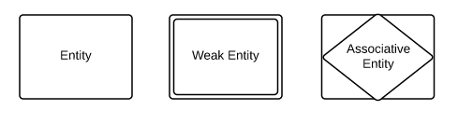

### 

Figure No: 4.1 Entity Symbol

### 4.8.2 Relationships

**Relationships** are meaningful associations between or among entities. They are usually verbs, e.g. assign, associate, or track. A relationship provides useful information that could not be discerned with just the entity types.

**Weak relationships**, or identifying relationships, are connections that exist between a weak entity type and its owner.

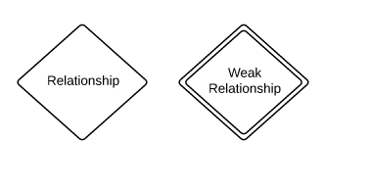

Figure No: 4.2 Relationship Symbol

### 4.8.3 Attributes

**Attributes** are characteristics of an entity, a many-to-many relationship, or a one-to-one relationship.

**Multi valued attributes** are those that are capable of taking on more than one value.

**Derived attributes** are attributes whose value can be calculated from related attribute values.

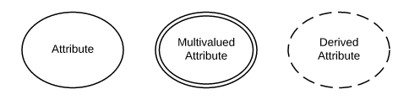

Figure No: 4.3 Attribute Symbol

### 4.8.4 Physical ERD Symbols

The symbols below are used at the most granular level of ERDs: physical data models, although some elements are also used for logical data models.

**Tables** are another way of representing entities.

**Fields** represent attributes of the entity.

**Keys** are one way to categorize attributes. A primary key is an attribute or combination of attributes that uniquely identifies one and only one instance of an entity. The primary key becomes a foreign key in any entity type to which it's related through a one-to-one or one-to-many relationship.

**Types** may refer to the type of data associated with the corresponding field in a table. Types can also refer to entity types, which describe the structure of an entity; e.g., a book's entity types are author, title, and published date.

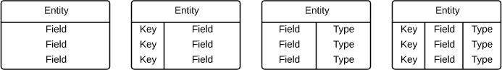

### 4.8.5 ERD Notation

* **Relationships** illustrate an association between two tables. In the physical data model, relationships are represented by stylized lines.
* **Cardinality** and **Ordinality** respectively, refer to the maximum number of times an instance in one entity can be associated with instances in the related entity, and the minimum number of times an instance in one entity can be associated with an instance in the related entity. Cardinality and ordinality are represented by the styling of a line and its endpoint, as denoted by the chosen notation style.

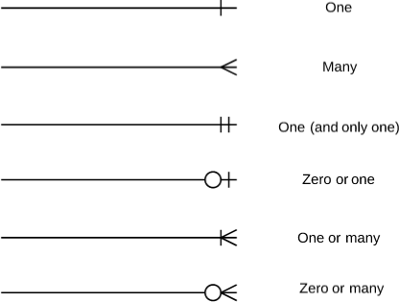

Figure No: 4.4 Cardinality Symbol

When it comes to notation, data modelers have many options to choose from. While crow's foot notation is widely accepted as the most intuitive style, some developers use OMT, IDEF, Bachman, or UML notation to indicate cardinality. Since crow's foot notation shows both minimum and maximum cardinality in an easy-to-read graphic format, lucid chart offers crow's foot notation as the preferred style.

## 4.9 Database Management System Models

Several database models have been commonly used but they all satisfy, in one way or another, the requirements to be a DBMS. The various database models are not even real databases because they store the data in flat files. Storing data in this model is very cumbersome and makes the data difficult to access.

### 4.9.2 Hierarchical

This model stores data in a hierarchical structure. An example of his database model is IMS.Many legacy databases used in minicomputers and mainframes still make use of the network and hierarchical database models.

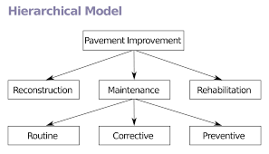

Figure No: 4.5 Hierarchical Models

### 4.9.3 Relational

A data model that represents data in the form of relations or tables. A relation is a named, two dimensional table of data. Each relation consists of a set of named columns and an arbitrary number of unnamed rows. Different DBMS are currently available in market which follow relational model i.e. Access, SQL Management Studio, **SQL Server**, Oracle and My SQL etc.

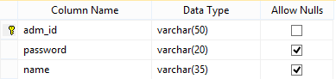

Table No: 4.1 Relational Models

### 4.9.4 Object Oriented

This model has become popular recently due to the limitations of traditional relational DBMS in handling complex data in non-transactional manner. In addition, these databases have found a niche in application such as CAD/CAM and multimedia.

## 4.10 Data base Design:

It means the design of a data base model that will support the Institute operations and objectives.

**The major aims of data base design are:**

* To represent the data and the relationships between data required by all major application areas and user groups.
* To provide a data model that support any transactions required on the data.
* To specify a design that will achieve the stated performance requirements for the system such as response time.

Unfortunately these aims are not always easy to achieve and sometimes require compromises to be made, particularly to achieve acceptable system performance. The two main approaches to the design of a data base system are referred to as the **top down** and **bottom up** approaches.

* **Bottom up approach:**

The bottom up approach begins at the fundamental level of attributes, which are grouped into entities and relationships. As the process continues we identify and add new relationships between entities. The process of normalization also represents a bottom up approach to design. This approach is suitable for simple databases having a small no. of attributes. Normalization involves the identification of the required attributes and their subsequent decomposition into normalized tables.

* **Top-down approach:**

It is suitable for designing complex databases. It starts with the development of data models that contain a few high level entities & then identify lower level entities, attributes & their relationships. It uses ER model, which shows the entities & their relationships, which are of interest to the Institute.

* **In our project we have used the top down approach.**

The Top down database design approach is composed of two major phases:

* **Logical database design.**
* **Physical database design.**

## 4.11 Data Flow Diagram:

A data flow diagram is a graphical representation that depicts information flow and the transforms that are applied as data move from input to output.

The basic form of a data flow diagram, also known as a data flow graph or a bubble chart, The data flow diagram may be used to represent a system or software at any level of abstraction.

As information moves through software, it is modified by a series of transformations. A data flow diagram is a graphical representation that depicts information flow and the transforms that are applied as data move from input to output. The basic form of a data flow diagram, also known as a *data flow graph* or a bubble chart. DFD is an abstract description of the system. The data flow diagram may be used to represent a system or software at any level of abstraction.

DFDs may be partitioned into levels that represent increasing information flow and functional detail. Therefore, the DFD provides a mechanism for functional modeling as well as information flow modeling. DFDs are very useful in understanding a system and can be effectively used during analysis.

DFDs can be hierarchically organized, which helps in progressively partitioning and analyzing large systems. Such DFDs are called *leveled DFDs. Context diagram is a diagram* in which the entire system is treated as a single process and all its inputs, outputs, sinks, and sources are identified and shown.

**DFD Symbol**

**Entity Flow of Data Process Data Store**

Figure No: 4.6 DFD Symbol

**Level 0 DFD**

Log out

Log in

Status

Admin

Password

Figure No: 4.7 DFD Levels 0

**Level 1 DFD**

User

Admin

User ID name

Password

Unsuccessful

Figure No: 4.8 DFD Levels 1

**Level 2 DFD**

Members

Administrator

WPDC DB

Visitor

Figure No: 4.9 DFD Levels 2

## 4.12 Physical Design

The purpose of physical database design is to translate the logical description of data into technical specification for storing and retrieving data. Its goal is to create such a design, which will store data and will provide adequate performance and insure database integrity, security, consistency and recoverability.

Designing physical files and databases, certain information is required that should have been collected and produced during prior development phases. The information needed for physical file and database design include the following requirements:

Normalized relations, including volume estimates

Definition of each attribute.

Description of data that where and when it will be used, entered, retrieved, deleted and updated?

Expectations or requirements for response time, data security, backup, recovery, retention and integrity.

Description of technologies (Database Management System) used for the development and implementation of the database.

The Automation of Silk Road Handicrafts Swat consists of the following physical files / relations.

## 4.13 Input Design

Input design is the second category, which prescribes the manner in which data is to be entered or fed into the computer and then to be processed to produce the desired outputs.

If the data entered is accurate and in correct format then desired outputs may be obtained otherwise there would be the problem of black hole, black hole means that the system has inputs but no outputs have been returned by the system. It means that the inputs entered to the system are not accurate or valid which gives no output. Input design is very important so that no wrong data is to be entered to the system and so no false or unexpected outputs will be faced.

In the input design following things must be followed carefully to achieve integrity of the system.

* What are the inputs?
* Types of inputs.
* Length of input data item.
* Source of input data item.

Input means data items entered to the system for processing. After reviewing and discussing thoroughly we collected the whole data items that has to be used in different database files.

Keyboard will be used as main input device however a mouse can also be used because the software which is going to be developed is in visual language so mouse can also be the hottest input device.

It is very important to define or declare the maximum length of data items in first attempt because one data item may be used in different places so its length must be specified before it is used.

By output design we mean the design produced by the system and the form in which it is to be produced. That is whether printed displayed or spoken. Output design is in important factor as the system success and failure largely depends on the output design therefore more attention is given to this output design. It is through these outputs that the system becomes useful to the user. Presently computer can produce two types of outputs i.e.

* **Output on Screen**
* **Output on Paper**

## 4.14 Data Dictionary

**Admin Login**

|  |  |  |  |  |
| --- | --- | --- | --- | --- |
| **Column Name** | **Data type** | **Field Size** | **Description** | **Identifier** |
| adm_id | Varchar | (50) | Admin ID | Primary Key |
| Password | Varchar | (20) | Password |  |
| Name | Varchar | (35) | Name |  |

Table 4.2 Admin Login

**Application Water**

|  |  |  |  |  |
| --- | --- | --- | --- | --- |
| **Column Name** | **Data type** | **Field Size** | **Description** | **Identifier** |
| app_no | Int | Default Size | App Number | Primary Key |
| vc_name | Varchar | (50) | Village Council | Foreign Key |
| Village_name | Varchar | (50) | Village Name | Foreign Key |
| Name | Varchar | (50) | Name |  |
| f_name | Varchar | (50) | Father Name |  |
| Nic | Varchar | (15) | NIC |  |
| Address | Varchar | (50) | Address |  |
| Date | Varchar | (50) | Date |  |
| Prob | Varchar | (250) | Problem |  |
| s_id | Varchar | (50) | Sectary ID | Foreign Key |

Table 4.3 Application Water

**Disable Record**

|  |  |  |  |  |
| --- | --- | --- | --- | --- |
| **Column Name** | **Data type** | **Field Size** | **Description** | **Identifier** |
| dis_id | Int | Default Size | ID | Primary Key |
| vc_name | Varchar | (50) | Village Council | Foreign Key |
| village_name | Varchar | (50) | Village Name | Foreign Key |
| Name | Varchar | (50) | Name |  |
| Nic | Varchar | (15) | NIC |  |
| Dob | Varchar | (15) | DOB |  |
| contact_no | Varchar | (15) | Contact Number |  |
| S_id | Varchar | (50) | Sectary ID | Foreign Key |

Table 4.4 Disable Record

**Birth Record**

|  |  |  |  |  |
| --- | --- | --- | --- | --- |
| **Column Name** | **Data type** | **Field Size** | **Description** | **Identifier** |
| B_id | Int | Default Size | Birth ID | Primary Key |
| vc_name | Varchar | (50) | Village Council | Foreign Key |
| village_name | Varchar | (50) | Village Name | Foreign Key |
| applicant_name | Varchar | (50) | Applicant Name |  |
| applicant_nic | Varchar | (15) | Applicant NIC |  |
| child_name | Varchar | (50) | Child Name |  |
| Gender | Varchar | (50) | Gender |  |
| f_name | Varchar | (50) | Father Name |  |
| f_nic | Varchar | (15) | Father NIC |  |
| m_name | Varchar | (50) | Mother Name |  |
| m_nic | Varchar | (15) | Mother NIC |  |
| Dob | Varchar | (50) | DOB |  |
| Address | Varchar | (50) | Address |  |
| s_id | Varchar | (50) | Sectary ID | Foreign Key |

Table 4.5 Birth Record

**Death Record**

|  |  |  |  |  |
| --- | --- | --- | --- | --- |
| **Column Name** | **Data type** | **Field Size** | **Description** | **Identifier** |
| d_id | Int | Default Size | Death ID | Primary Key |
| vc_name | Varchar | (50) | Village Council | Foreign Key |
| village_name | Varchar | (50) | Village Name | Foreign Key |
| applicant_name | Varchar | (50) | Applicant Name |  |
| applicant_nic | Varchar | (15) | Applicant NIC |  |
| Name | Varchar | (50) | Name |  |
| Nic | Varchar | (15) | NIC |  |
| Gender | Varchar | (50) | Gender |  |
| f_name | Varchar | (50) | Father Name |  |
| f_nic | Varchar | (15) | Father NIC |  |
| Dob | Varchar | (50) | Date of Birth |  |
| Dod | Varchar | (50) | Date of Death |  |
| Address | Varchar | (50) | Address |  |
| s_id | Varchar | (50) | Sectary ID | Foreign Key |

Table 4.6 Death Record

**District**

|  |  |  |  |  |
| --- | --- | --- | --- | --- |
| **Column Name** | **Data type** | **Field Size** | **Description** | **Identifier** |
| Dis_name | Varchar | (50) | District Name | Primary Key |

Table 4.7 District

**In fund**

|  |  |  |  |  |
| --- | --- | --- | --- | --- |
| **Column Name** | **Data type** | **Field Size** | **Description** | **Identifier** |
| s_no | Int | Default | Serial Number | Primary Key |
| Amount | Varchar | (50) | Amount |  |
| Source | Varchar | (50) | Source |  |
| Date | Varchar | (50) | Date |  |
| S_id | Varchar | (50) | Sectary ID | Foreign Key |

Table 4.8 In fund

**Out fund**

|  |  |  |  |  |
| --- | --- | --- | --- | --- |
| **Column Name** | **Data type** | **Field Size** | **Description** | **Identifier** |
| s_no | Int | Default Size | Seriel Number | Primary Key |
| Amount | Varchar | (50) | Amount |  |
| exp_all | Varchar | (50) | Expenditure All |  |
| Date | Varchar | (50) | Date |  |
| S_id | Varchar | (50) | Sectary ID | Foreign Key |

Table 4.9 Out fund

**Poor Record**

|  |  |  |  |  |
| --- | --- | --- | --- | --- |
| **Column Name** | **Data type** | **Field Size** | **Description** | **Identifier** |
| p_id | Int | Default Size | News ID | Primary Key |
| Name | Varchar | (50) | Name |  |
| f_name | Varchar | (50) | Father Name |  |
| Dob | Varchar | (50) | DOB |  |
| contact_no | Varchar | (15) | Contact No |  |
| village_council | Varchar | (50) | Village Council | Foreign Key |
| Village | Varchar | (50) | Village | Foreign Key |
| Way | Varchar | (50) | Way |  |
| S_id | Varchar | (50) | Sectary ID | Foreign Key |

Table 4.10 Poor Record

**Marriage Record**

|  |  |  |  |  |
| --- | --- | --- | --- | --- |
| **Column Name** | **Data type** | **Field Size** | **Description** | **Identifier** |
| m_id | Int | Default Size | Marriage ID | Primary Key |
| dulha_name | Varchar | (50) | Dulha Name |  |
| dulha_nic | Varchar | (15) | Dulha NIC |  |
| f_namedulha | Varchar | (50) | Father Name Dulha |  |
| f_dulha_nic | Varchar | (15) | Father Dulha NIC |  |
| Age | Varchar | (50) | Age |  |
| Status | Varchar | (50) | Status |  |
| address_dulha | Varchar | (50) | Address Dulha |  |
| union_council | Varchar | (50) | Union Council |  |
| Tehsil | Varchar | (50) | Tehsil |  |
| District | Varchar | (50) | District |  |
| marriage_date | Varchar | (50) | Marriage Date |  |
| dulhan_name | Varchar | (50) | Dulhan Name |  |
| dulhan_nic | Varchar | (15) | Dulhan NIC |  |
| f_namedulhan | Varchar | (50) | Father Name Dulhan |  |
| f_dulhan_nic | Varchar | (50) | Father Dulhan NIC |  |
| age_at_marriage | Varchar | (50) | Age at Marriage |  |
| address_dulhan | Varchar | (50) | Address Dulhan |  |
| mehr_amount | Int | Default Size | Mehr Amount |  |
| Detail_mehr | Varchar | (50) | Detail Mehr |  |
| S_id | Varchar | (50) | Sectary ID | Foreign Key |

Table 4.11 Marriage Record

**School Information**

|  |  |  |  |  |
| --- | --- | --- | --- | --- |
| **Column Name** | **Data type** | **Field Size** | **Description** | **Identifier** |
| School_name | Varchar | (50) | School Name | Primary Key |
| Vc_name | Varchar | (50) | Village Council | Foreign Key |
| Village_name | Varchar | (50) | Village Name | Foreign Key |
| Code | Varchar | (50) | Code |  |
| Headmaster_name | Varchar | (50) | Headmaster Name |  |
| Contact_no | Varchar | (15) | Contact Number |  |
| S_id | Varchar | (50) | Sectary ID | Foreign Key |

Table 4.12 School Information

**School PTC**

|  |  |  |  |  |
| --- | --- | --- | --- | --- |
| **Column Name** | **Data type** | **Field Size** | **Description** | **Identifier** |
| ptc_id | Int | Default | PTC ID | Primary Key |
| vc_name | Varchar | (50) | Village Council | Foreign Key |
| village_name | Varchar | (50) | Village Name | Foreign Key |
| school_name | Varchar | (50) | School Name |  |
| ptc_accountno | Varchar | (50) | PTC Account Number |  |
| bank_name | Varchar | (50) | Bank Name |  |
| bank_branch | Varchar | (50) | Bank Branch |  |
| present_balance | Varchar | (50) | Present Balance |  |
| Chairman | Varchar | (50) | Chairman |  |
| vice_chairman | Varchar | (50) | Vice Chairman |  |
| member_parent | Varchar | (50) | Member Parent |  |
| S_id | Varchar | (50) | Sectary ID | Foreign Key |

Table 4.13 School PTC

**Tehsil**

|  |  |  |  |  |
| --- | --- | --- | --- | --- |
| **Column Name** | **Data type** | **Field Size** | **Description** | **Identifier** |
| tehsil_name | Varchar | (50) | Tehsil Name | Primary Key |
| district_name | Varchar | (50) | District Name | Foreign Key |

Table 4.14 Tehsil

**School Strengths**

|  |  |  |  |  |
| --- | --- | --- | --- | --- |
| **Column Name** | **Data type** | **Field Size** | **Description** | **Identifier** |
| sth_id | Int | Default Size | Sthrength ID | Primary Key |
| vc_name | Varchar | (50) | Village Council | Foreign Key |
| village_name | Varchar | (50) | Village Name | Foreign Key |
| school_name | Varchar | (50) | School Name |  |
| Class | Varchar | (50) | Class |  |
| male_student | Varchar | (50) | Male Student |  |
| female_student | Varchar | (50) | Female Student |  |
| total_student | Varchar | (50) | Total Student |  |
| classteacher_name | Varchar | (50) | Class Teacher Name |  |
| Salary | Varchar | (50) | Salary |  |
| S_id | Varchar | (50) | Sectary | Foreign Key |

Table 4.15 School Strength

**School Facilities**

|  |  |  |  |  |
| --- | --- | --- | --- | --- |
| **Column Name** | **Data type** | **Field Size** | **Description** | **Identifier** |
| f_id | Int | Default | Facility ID | Primary Key |
| vc_name | Varchar | (50) | Village Council | Foreign Key |
| village_name | Varchar | (50) | Village Name | Foreign Key |
| school_name | Varchar | (50) | School Name |  |
| total_room | Varchar | (50) | Total Room |  |
| Electricity | Varchar | (50) | Electricity |  |
| Water | Varchar | (50) | Water |  |
| boundary_wall | Varchar | (50) | Boundary Wall |  |
| teacher_washroom | Varchar | (50) | Teacher Washroom |  |
| student_washroom | Varchar | (50) | Student Washroom |  |
| S_id | Varchar | (50) | Sectary | Foreign Key |

Table 4.16 School Facilities

**Sectary**

|  |  |  |  |  |
| --- | --- | --- | --- | --- |
| **Column Name** | **Data type** | **Field Size** | **Description** | **Identifier** |
| s_id | Int | Deafult Size | Sectary ID | Primary Key |
| vc_name | Varchar | (50) | Village Council | Foreign Key |
| village_name | Varchar | (50) | Village Name | Foreign Key |
| Name | Varchar | (50) | Name |  |
| Nic | Varchar | (15) | NIC |  |
| f_name | Varchar | (50) | Father Name |  |
| Email | Varchar | (50) | Email |  |
| Password | Varchar | (20) | Password |  |
| contact_no | Varchar | (15) | Contact Number |  |
| date_hirring | Varchar | (50) | Date of Hiring |  |
| Tehsil | Varchar | (50) | Tehsil |  |
| District | Varchar | (50) | District |  |
| Address | Varchar | (50) | Address |  |

Table 4.17 Sectary

**Village**

|  |  |  |  |  |
| --- | --- | --- | --- | --- |
| **Column Name** | **Data type** | **Field Size** | **Description** | **Identifier** |
| village_name | Varchar | (50) | Village Name | Primary Key |
| vc_name | Varchar | (50) | Village Council | Foreign Key |

Table 4.18 Village

**Village Council**

|  |  |  |  |  |
| --- | --- | --- | --- | --- |
| **Column Name** | **Data type** | **Field Size** | **Description** | **Identifier** |
| vc_name | Varchar | (50) | Village Council | Primary Key |
| tehsil_name | Varchar | (50) | Tehsil Name | Foreign Key |

Table 4.19 Village Council

**Member**

|  |  |  |  |  |
| --- | --- | --- | --- | --- |
| **Column Name** | **Data type** | **Field Size** | **Description** | **Identifier** |
| m_id | Varchar | (50) | Member ID | Primary Key |
| Name | Varchar | (50) | Name |  |
| f_name | Varchar | (50) | Father Name |  |
| Nic | Varchar | (50) | NIC |  |
| Email | Varchar | (50) | Email |  |
| Password | Varchar | (20) | Password |  |
| Position | Varchar | (50) | Position |  |

Table 4.20Member

## 4.15 Entity with Attribute

**Admin Login**

Admin

Figure No 4.10 Admin Login

**Application Water**

Application Water

Figure No 4.11 Application Water

**Birth Record**

Birth Record

Figure No 4.12 Birth Record

**Death Record**

Death Record

Figure No 4.13 Death Record

**Disable Record**

Figure No 4.14 Disable Record

Disable Record

**In fund**

In fund

Figure No 4.15 In fund

## 

**Out fund**

Out fund

Figure No 4.16 Out fund

**Marriage Record**

Marriage Record

Figure No 4.17 Marriage Record

**Poor Record**

Poor Record

Figure No 4.18 Poor Record

**School Information**

School Information

Figure No 4.19 School Information

**School PTC**

School PTC

Figure No 4.20 School PTC

**School Strength**

School Strength

Figure No 4.21 School Strength

**School Facilities**

School Facilities

Figure No 4.22 School Facilities

**Secretary**

Sectary

Figure No 4.23 Sectary

**Tehsil**

Tehsil

Figure No 4.24 Tehsil

**Village**

Village

Figure No 4.25 Village

**Village Council**

Village Council

Figure No 4.26 Village Council

## 4.17 Database Diagram

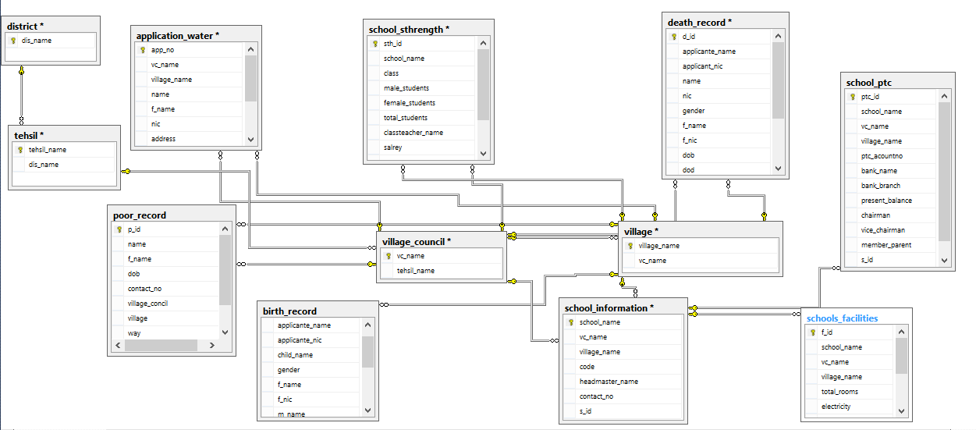

Figure No 4.27 Database Diagram

## 5.1 Connection String

publicclassClass1

{

Public String cons = "Data Source=.\\SQLEXPRESS;AttachDbFilename=|DataDirectory|Database.mdf;Integrated Security=True; User Instance=True";

}

## 5.2 Login

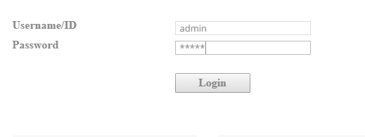

Figure No: 5.1 Admin login

**Note**: by Providing Admin ID and Password administrator of System can access website after providing these information admin click on button below then system check the information if account exist then server transfer control to main page otherwise show error message.

Protected void Button1_Click (object sender, EventArgs e)

{

// Button: Login

SqlCommand cmd = new SqlCommand ("select * from admin where adm_id='"txtID.Text + "' and password='" + txtPwd.Text + "'",con);

SqlDataReader r;

con.Open();

r = cmd.ExecuteReader ();

if (r.Read())

{

Response. Redirect("AdminHome.aspx");

}

else

{

r.Close ();

con.Close();

lblmsg.Text = "Invalid Username/ID or password";

lblmsg.ForeColor = Color.Red;

}

}

## 5.3 Add Record

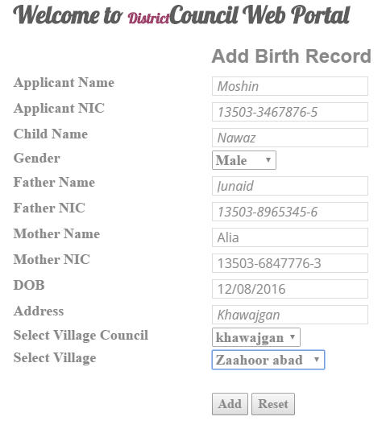

Figure 5.2 Add record

Protectedvoid Button1_Click (object sender, EventArgs e)

SqlCommand cmd = new SqlCommand ("select * from birth_record where b_id= '"+txtbid.Text+"'",con);

SqlDataReader r;

con.Open ();

r = cmd.ExecuteReader ();

if (r.Read())

{

r.Close();

con.Close();

lblmsg.Text = "Record Already Exist";

txtbid.Focus();

}

else

{

r.Close ();

con.Close();

SqlCommand cmd1 = new SqlCommand("insert into birth_record (b_id,applicante_name,applicante_nic,child_name,gender,f_name,f_nic,m_name,m_nic,dob,address,vc_name,vilage_name)values('"+txtbid.Text+"','"+txtapplicantname.Text+"','"+txtapplicantnic.Text+"','"+txtchildname.Text+"','"+drpgender.SelectedIndex+"','"+txtfname.Text+"','"+txtfnic.Text+"','"+txtmname.Text+"','"+txtmnic.Text+"','"+txtdob.Text+"','"+txtaddress.Text+"','"+drpvcname.SelectedItem+"','"+drpvillagename.SelectedItem+"')",con);

con.Open();

cmd1.ExecuteNonQuery ();

con.Close ();

lblmsg.Text = "Record Saved";

}

}

## 5.4 Edit Record

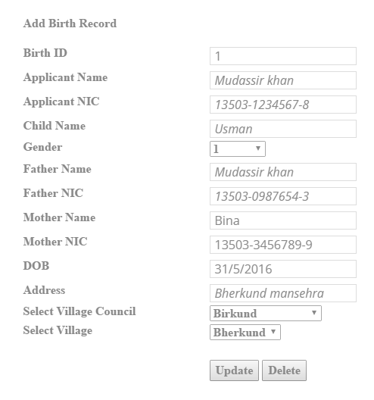

Figure 5.3 Edit Birth Record

Protectedvoid Button1_Click (object sender, EventArgs e)

SqlCommand cmd = new SqlCommand ("select * from birth_record where b_id= '" + txtbid.Text + "'", con);

con.Open ();

SqlDataReader r;

r = cmd.ExecuteReader ();

if (r.Read())

{

r.Close ();

con.Close ();

SqlCommand cmd1 = new SqlCommand("update birth_record set applicante_name='" + txtapplicantname.Text+ "',applicante_nic='" +txtapplicantnic.Text + "', child_name='" + txtchildname.Text + "', gender='" + drpgender.SelectedItem + "', f_name='" + txtfname.Text + "',f_nic='" + txtfnic.Text + "', m_name='" + txtmname.Text + "',m_nic='"+txtmnic.Text+"',dob='"+txtdob.Text+"',address='"+txtaddress.Text+"',vc_name='"+drpvcname.SelectedItem+"',vilage_name='"+drpvillagename.SelectedItem+"'where b_id='"+txtbid.Text+"'", con);

con.Open ();

cmd1.ExecuteNonQuery ();

con.Close ();

lblmsg.Text = "Record Updated Successfully";

lblmsg.ForeColor = Color.Green;

}

else

{

r.Close ();

con.Close ();

lblmsg.Text = "Record Not exist or either deleted";

lblmsg.ForeColor = Color. Green;

}

}

### 5.4.1 Delete Record

protected void Button2_Click(object sender, EventArgs e)

{

SqlCommand cmd = new SqlCommand ("select * from birth_record where b_id= '" + txtbid.Text+ "'", con);

con.Open ();

SqlDataReader r;

r = cmd.ExecuteReader ();

if (r.Read())

{

r.Close ();

con.Close ();

SqlCommand cmd1 = new SqlCommand ("delete from birth_record where b_id='" + txtbid.Text + "'", con);

con.Open ();

cmd1.ExecuteNonQuery ();

con.Close ();

lblmsg.Text = "Record Deleted Successfully";

lblmsg.ForeColor = Color. Green;

}

else

{

r.Close ();

con.Close ();

lblmsg.Text = "Record Not exist or either deleted";

lblmsg.ForeColor = Color. Green;

}

}

## 5.5 View Record

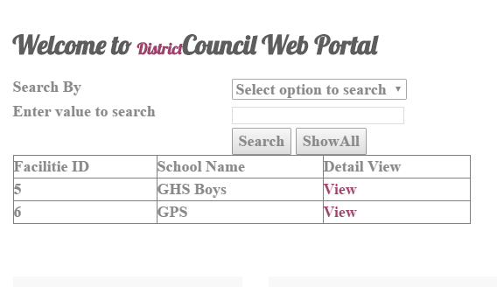

Figure 5.4 View record

protected void Page Load(object sender, EventArgs e)

{

con = new SqlConnection (obj.cons);

SqlDataAdapter ad = new SqlDataAdapter ("select * from birth_record", con);

DataSet ds = new DataSet ();

ad. Fill(ds);

GridView1.DataSource = ds;

GridView1.DataBind();

}

## 5.6 View Detail

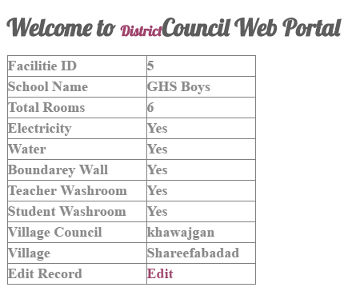

Figure 5.5 View Detail

protected void Page Load(object sender, EventArgs e)

{

con = new SqlConnection (obj.cons);

birth = Context.Request.QueryString ["abc"].ToString();

SqlDataAdapter ad = new SqlDataAdapter ("select * from birth_record where b_id='" + birth + "'", con);

DataSet ds = new DataSet ();

ad. Fill (ds);

DetailsView1.DataSource = ds;

DetailsView1.DataBind ();

}

}

DetailsView1.DataBind();

}

## 5.7 Reading Foreign Key

private void readvc()

{

SqlCommand cmd = new SqlCommand("select * from village_council",con);

SqlDataReader r;

con.Open();

r = cmd.ExecuteReader();

while (r.Read())

{

drpvcname.Items.Add(r["vc_name"].ToString());

}

r.Close();

con.Close();

}

## 6.1 Testing Strategies

After completion of coding reviewing software and check all queries, then procedures, output, input values and triggers. We check buttons to see that they work properly check alert on execution on time and check report information for errors. Testing begins at the component level and works towards the integration of entire computer based system. 6.1.1 Verification and Validation

Software testing is one element of a broader topic that is defined as verification and validation. Verification; are we building the right ‘Validation; are we building the right product’.

Verification and validation encompasses wide array activities that includes formal technical review, quality and configuration audits, performance monitoring, simulation feasibility study, algorithms analysis, documentation review, database review, development testing, qualification testing and installation testing.

### 6.1.2 System Testing

While developing Online System, there is tendency to push the end product “out the door “as soon as possible .Most of the time, Online projects are not estimated properly and tend to run behind schedule. When it comes to meeting the deadline, people seem to ignore a very important phase in the whole process testing. But our project has been thoroughly tested by us.

System testing is an essential step for the development of a reliable and error-free system. Testing is a process of executing a program with the explicit intension of finding errors but this does not mean to embarrass the programmer or fail the product but the positive intention to remove the problems. A test case is a set of data items that the system processes as normal input. For e.g. some alerts Special Symbols not allowed, invalid email or invalid contact no etc. Good testing involves much more than just running the program a few times to see whether it works. A successful test is the one that finds error. Here we show some alerts while input data

### 6.1.3 Test Cases

A good test case is one that uses the control structures of the procedural design to drive test cases. White box testing of software is predicated on close examination of procedural detail. Using white box testing methods, the software engineer can drive test case that?

* Guarantee that all independents paths within a module have been exercised at least once.
* Exercise all decisions on their true and false side.
* Execute all loops at their boundaries and within their operational bonds.
* Exercise internal data structures to assure data validity.

**Test Case # 1**

**Test Case Title:** Testing the Login mechanism of **Web Portal for District Council**

|  |
| --- |
| **Precondition :**Member must be registered already |
| **Input test data:** correct username, correct password |
| **Steps to be executed:**  1)Enter input(correct )username and password on the respective fields  2)click login |
| **Expected Results:** System should login the user into the system. |
| **Tested By:** Fahad Rashid |
| **Result :** Pass |

**Test Case # 2**

**Test Case Title:** Test if unauthorized users are not able to login to the Web Portal system

|  |
| --- |
| **Precondition :** Member do not have Registered Account |
| **Input test data:** incorrect username, incorrect password |
| **Steps to be executed:**  1)Enter input(incorrect )username and password on the respective fields  2)click login |
| **Expected Results:** System should provide error message. |
| **Tested By:** Fahad Rashid |
| **Result :** Pass |

**Test Case # 3**

**Test Case Title:** Test with valid username and empty password such that login must get failed

|  |
| --- |
| **Precondition :**Member must be registered already |
| **Input test data:** valid username and empty password |
| **Steps to be executed:**  1)enter the valid username in the user id and enter no password in the password field |
| **Expected Results:** System should provide error message. |
| **Tested By:**  Fahad Rashid |
| **Result :** Pass |

**Test Case # 4**

**Test Case Title:** Test with empty username and valid password such that login must get failed

|  |
| --- |
| **Precondition :**registered member's password |
| **Input test data:** Empty username and valid password |
| **Steps to be executed:**   1. leave the username empty in the user id and enter a valid user's password in the password field |
| **Expected Results:** System should provide error message. |
| **Tested By:** Fahad Rashid |
| **Result :** Pass |

**Test Case # 5**

**Test Case Title:** Test with empty username and empty password and check if login fails

|  |
| --- |
| **Precondition :**registered member's password |
| **Input test data:** Empty username and empty password |
| **Steps to be executed:**  1)Enter nothing in the user id and password field  2)click login button |
| **Expected Results:** System should provide error message. |
| **Tested By:** Fahad Rashid |
| **Result :** Pass |

**Change Password Test Cases**

**Test Case # 6**

**Test Case Title:** Admin Change Password

|  |
| --- |
| **Precondition :**Admin Already Login to System |
| **Input test data:** Click on the Change Password link3.  Check whether the Change password Page is loaded. |
| **Steps to be executed:**   1. Click on the Change Password link3. 2. Check whether the Change password Page is loaded. 3. Check whether there are 3 text fields for Old Password, 4. New Password and Re-type new password |
| **Expected Results:** System should provide error message. |
| **Tested By:** Fahad Rashid |
| **Result :** Pass |

**Test Case # 7**

**Test Case Title:** Admin Change Password

|  |
| --- |
| **Precondition :** Already Login to System |
| **Input test data:** Without entering any passwords, try to submit the page |
| **Steps to be executed:**   1. Enter some blank spaces or empty field |
| **Expected Results:** System should provide error message. |
| **Tested By:** Fahad Rashid |
| **Result :** Pass |

**Test Case # 8**

**Test Case Title:** Admin Change Password

|  |
| --- |
| **Precondition :** Already Login to System |
| **Input test data:** Old Password, Enter new password and re-type new password |
| **Steps to be executed: Click on change button** |
| **Expected Results:** System should provide successful password change message. |
| **Tested By:** Fahad Rashid |
| **Result :** Pass |

**Save Record**

**Test Case # 9**

**Test Case Title:** Save Information

|  |
| --- |
| **Precondition :**Already Login to System |
| **Input test data:** Enter Proper Record |
| **Steps to be executed:** Click on save Button |
| **Expected Results:** System should provide record saved message. |
| **Tested By:** Mudassir Ashraf |
| **Result :** Pass |

**Test Case # 10**

**Test Case Title:** Save Information

|  |
| --- |
| **Precondition :**Already Login to System |
| **Input test data:** Enter Record that is already in database |
| **Steps to be executed:** Click on save Button |
| **Expected Results:** System should provide record error message. |
| **Tested By:** Mudassir Ashraf |
| **Result :** Pass |

**Update Record**

**Test Case # 11**

**Test Case Title:** Update Information

|  |
| --- |
| **Precondition :**Already Login to System |
| **Input test data:** Enter Record that is already in database |
| **Steps to be executed:** Click on save Update |
| **Expected Results:** System should provide record updated message. |
| **Tested By:** Mudassir Ashraf |
| **Result :** Pass |

**Update Record**

**Test Case # 12**

**Test Case Title:** Update Information

|  |
| --- |
| **Precondition :**Already Login to System |
| **Input test data:** Enter Improper Values in field |
| **Steps to be executed:** Click on save Update |
| **Expected Results:** System should provide error message. |
| **Tested By:** Mudassir Ashraf |
| **Result :** Pass |

**View Users Record**

**Test Case # 13**

**Test Case Title:** View all member Information

|  |
| --- |
| **Precondition :**Administrator Login to System |
| **Input test data:** Select View User Link |
| **Steps to be executed:** View Information |
| **Expected Results:** System should display all users record |
| **Tested By:** Mudassir Ashraf |
| **Result :** Pass |

**Insert Record**

**Test Case # 14**

**Test Case Title:** Add marriage record

|  |
| --- |
| **Precondition :**Sectary Login to System |
| **Input test data:** Don’t add Values |
| **Steps to be executed:** Clicking on Save Button |
| **Expected Results:** System should provide error message. |
| **Tested By:** Mudassir Ashraf |
| **Result :** Pass |

**Test Case # 15**

**Test Case Title:** add marriage record

|  |
| --- |
| **Precondition :**Sectary Login to System |
| **Input test data:** Enter Record that is already in database |
| **Steps to be executed:** Click on Submit button |
| **Expected Results:** System should provide Error message |
| **Tested By:** Mudassir Ashraf |
| **Result :** Pass |

### 6.1.4 Computer Program Testing

On completion of the whole program, each module was again run from the main menu and was again tested by applying pretends data to it, for this purpose heavy data was applied to it to ensure that system is working still accurately. A large number of data is given to this project and it was tested with that data, which could not produce any errors in the project so the new system is fully tested and debugged, thus it may be implemented.

### 6.1.5 Code Testing

These codes are test independently. All data are check with full concentration we translate the common business term and language into appropriate programming language, which is difficult task. Standard walkthrough are then used to ensure semantics correctness of code. Then correctness verification is conducted for the source code.

Coding

using System;

using System.Collections.Generic;

using System.Linq;

using System.Web;

using System.Web.UI;

using System.Web.UI.WebControls;

using System.Data;

using System.Data.SqlClient;

using System.Drawing;

public partial class AdminLoign : System.Web.UI.Page

{

my_code_file obj1 = new my_code_file();

SqlConnection con;

protected void Page_Load (object sender, EventArgs e)

{

// Load Event

con = new SqlConnection (obj1.cons);

}

protected void Button1_Click(object sender, EventArgs e)

{

// Button : Login

SqlCommand cmd = new SqlCommand("select * from admin where adm_id='" + txtID.Text + "' and password='" + txtPwd.Text + "'",con);

SqlDataReader r;

con.Open();

r = cmd.ExecuteReader();

if (r.Read())

{

r.Close();

con.Close();

// creating session

Session["uid"] = txtID.Text;

Response.Redirect ("SuperAdminHome.aspx");

}

else

{

r.Close ();

con.Close ();

lblmsg.Text = "Invalid Username/ID or password";

lblmsg.ForeColor = Color.Red;

}

}

}

## 6.2 Software Testing Report

This report includes that approximately all tests are conducted and errors are removed from software so it is ready to use.

### 6.2.1 Data

Data is more important element in database. It provides the base on which all the building from its source, which is form to it, destination, which is table. The order may change; we assure that all data move on its correct path.

### 6.2.2 Procedures and Functions

The procedures are important in testing they involve calculation of mathematics. Majority of input data is of tables we check all tables, their fields, data type, and length. But in front hand, which used by end user if the mistake is occurs like invalid data to text box the error message is display we check every text box and errors. The out of forms and fields are also tested. All field checks are show above in system testing.

### 6.2.3 GUI Interface

Interfaces are tested and it is also assured that user navigate through the screens without any errors.

## 6.4 Implementation Testing

Implementation means the process of transforming present manual system into new computerized system or web-based system. There are several options available for conversion. In data processing conversion is defined as the process of changing:

* From one data processing system to another.
* From one from of representation to the other.

Implementation of project involves the following activities.

* Planning and scheduling of the implementation processes.
* Organizational planning and personal administration.
* Final system designed and testing.
* Establishment of standard of performance and control procedures and conversion from old to new system.

## 7.1 Home Screen

Home page is main page of our website which provide all links to user. For a Web user, the home page is the first Web page that is displayed after starting a Web browser like Netscape's Navigator or Google Chrome. The browser is usually preset so that the home page is the first page of the browser manufacturer. However, you can set it to open to any Web site. For example, you can specify that or "localhost:default.aspx" be your home page.

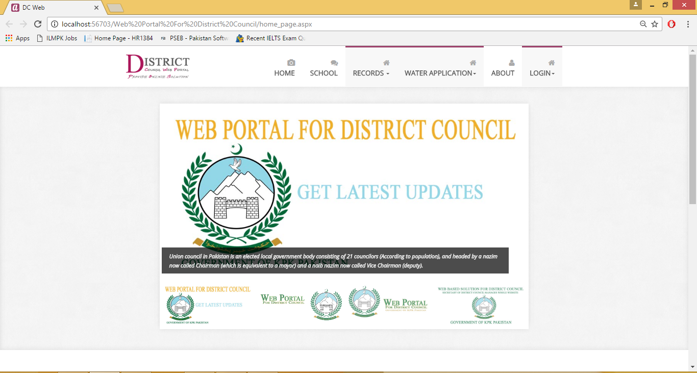

Figure 7.1-Home Screen

## 7.2 Login

Login page is used for validation. Only valid user can login by providing his/ her User ID and password.

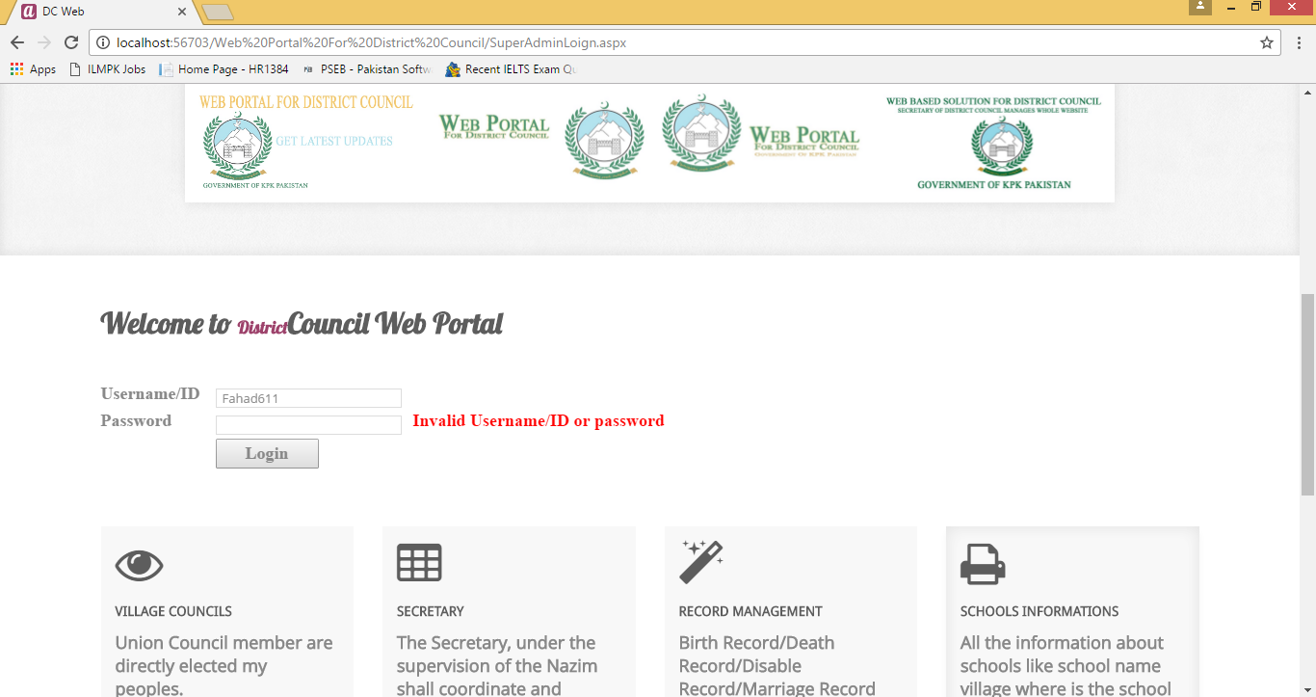

Figure 7.2 Login

## 

## 7.3 Add Application

Application is added by using add application web form.

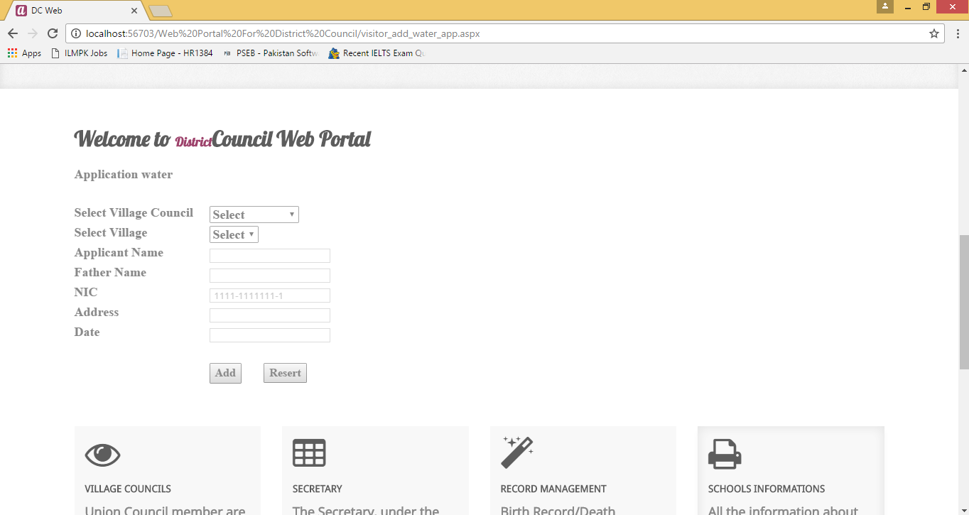

Figure 7.3 Add Application

## 7.4 Add Birth Record

Administrator can add new birth by providing Birth id, Applicant Name, Application NIC, Child Name, Gender, Father Name, Father NIC, Mother Name, Mother NIC, DOB, Address, Village Council and Village.

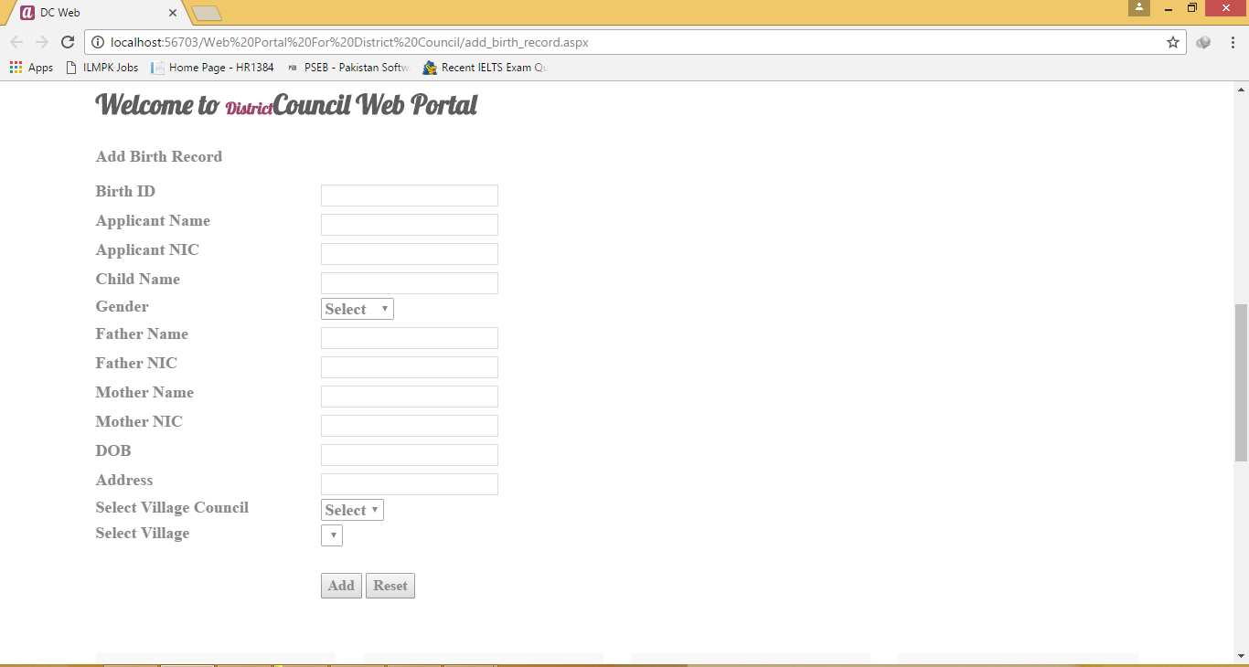

Figure 7.4 Add Birth Record

## 

## 7.5 Add Death Record

Administrator can add new Death ID, Applicant Name, Applicant NIC, Name, NIC, Gender, Father Name, Father NIC, DOB, DOD, Village Council, Village and Address.

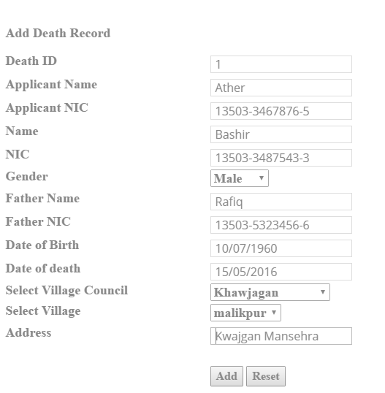

Figure 7.5 Add Death Record

## 7.6 Add School Information

This web form is used to add teacher information. User fill all values in web form then store these values by clicking on “Add” button.

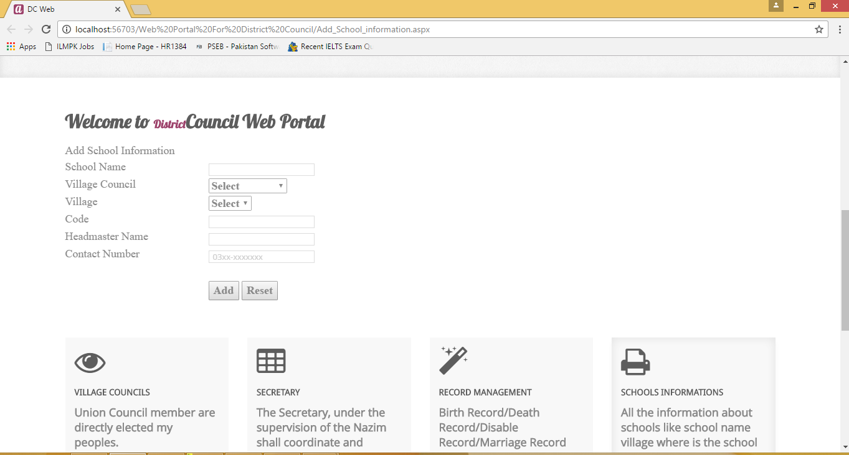

Figure 7.6 School Information

**7.7 View School Information**

School information is displayed on this web form.

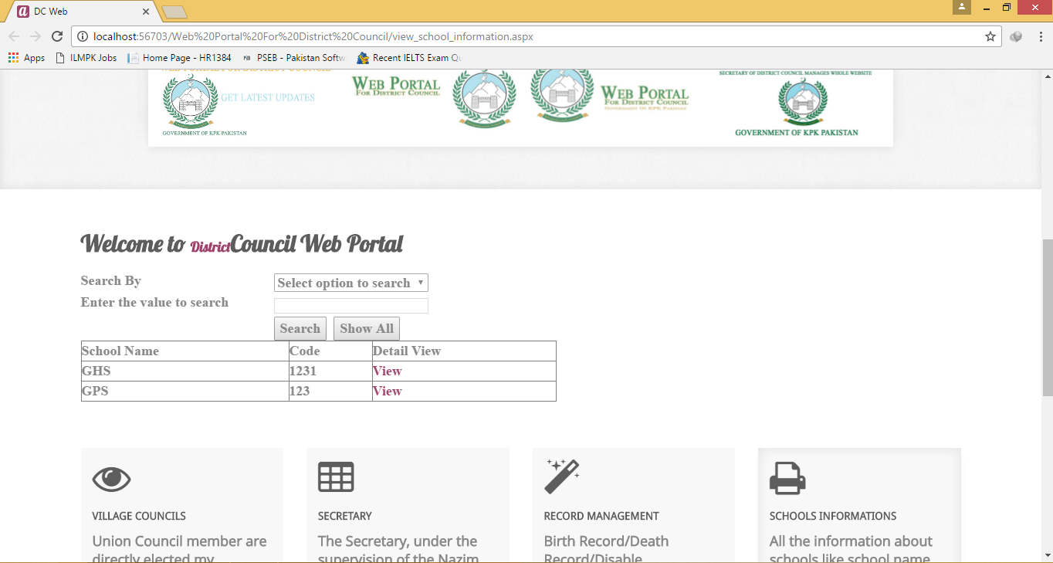

Figure 7.7 View School Information

## 7.8 View School Information Detail

User can view detail information of School.

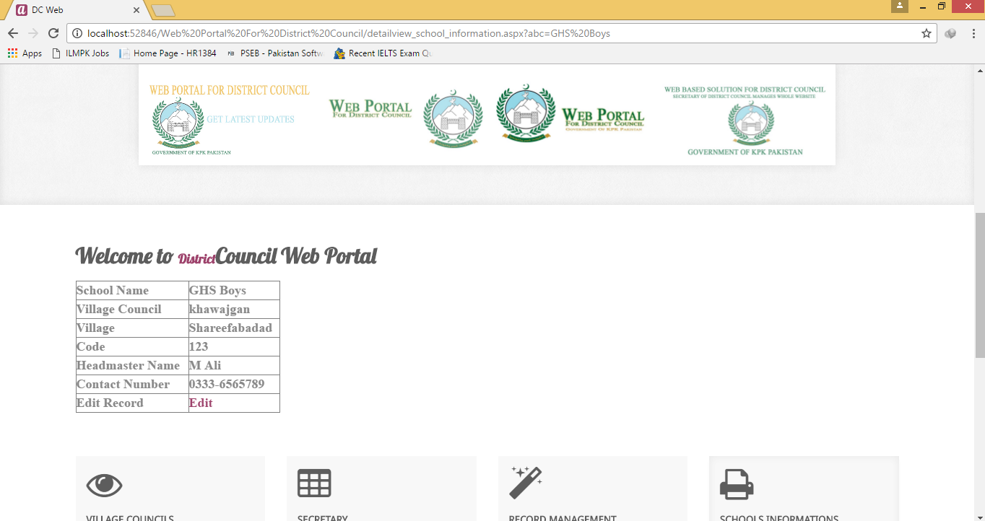

Figure 7.8 View School Information Detail

**7.9 Add Sectary**

Admin of System can add Sectary information.

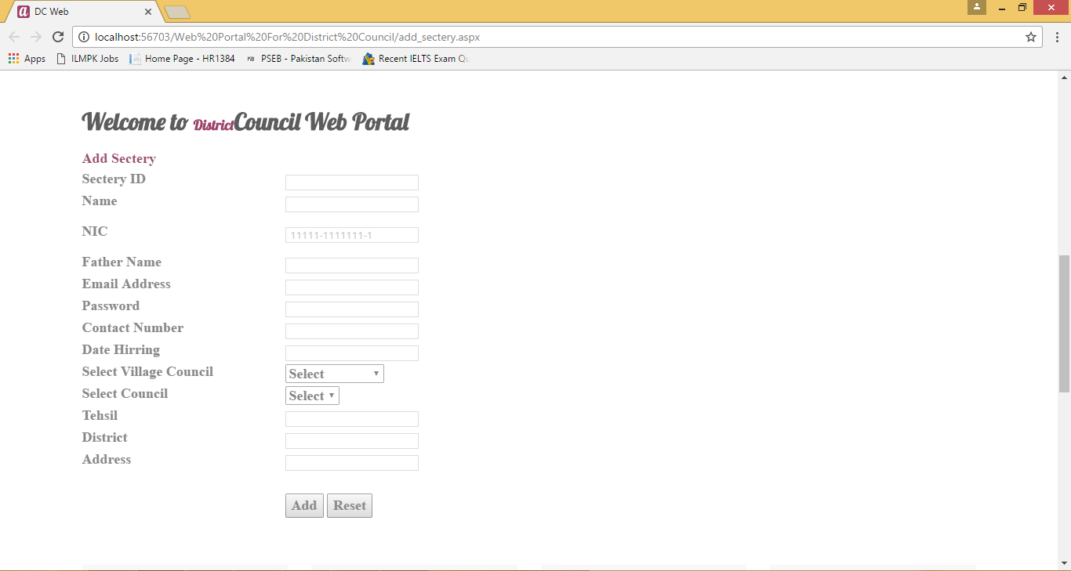

Figure 7.9 Add Sectary

## 7.10 View Sectary Information

Sectary information can be viewed by this web form.

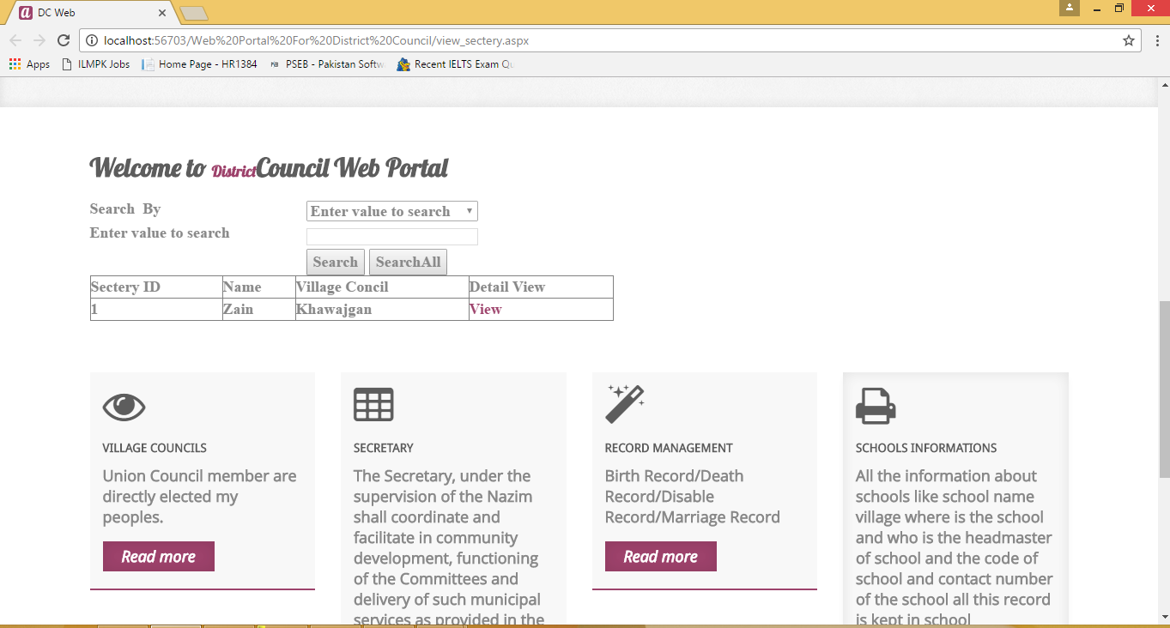

Figure 7.10 View Sectary Information

## 7.11 Sectary Detail

User can view detail information of sectary.

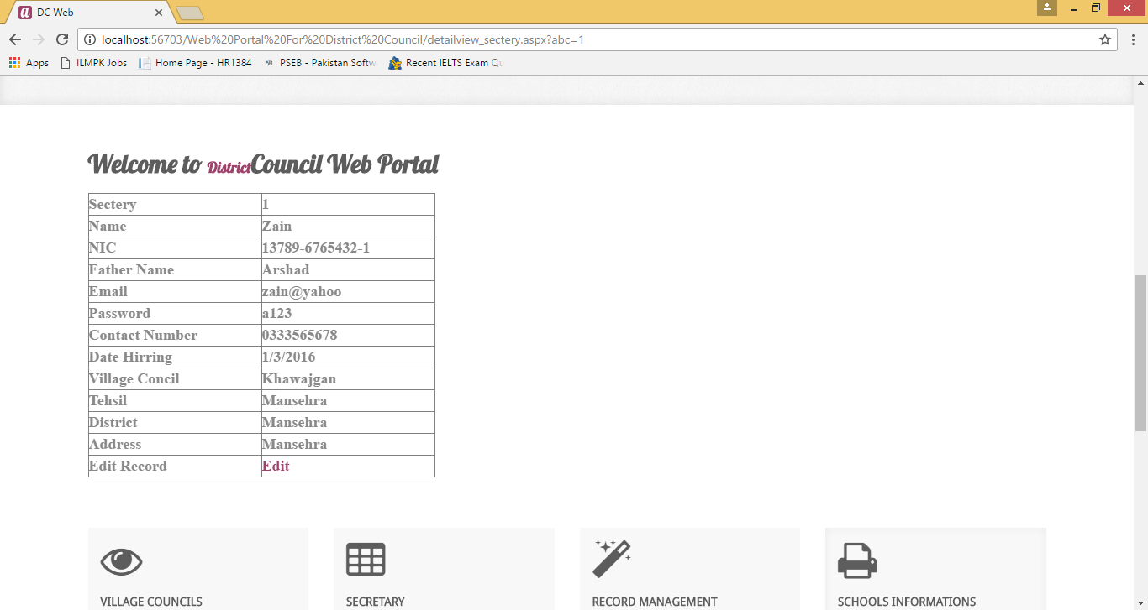

Figure 7.11 Sectary Detail

## 7.12 Change Sectary Password

Sectary can change their password and get new password in this web form.

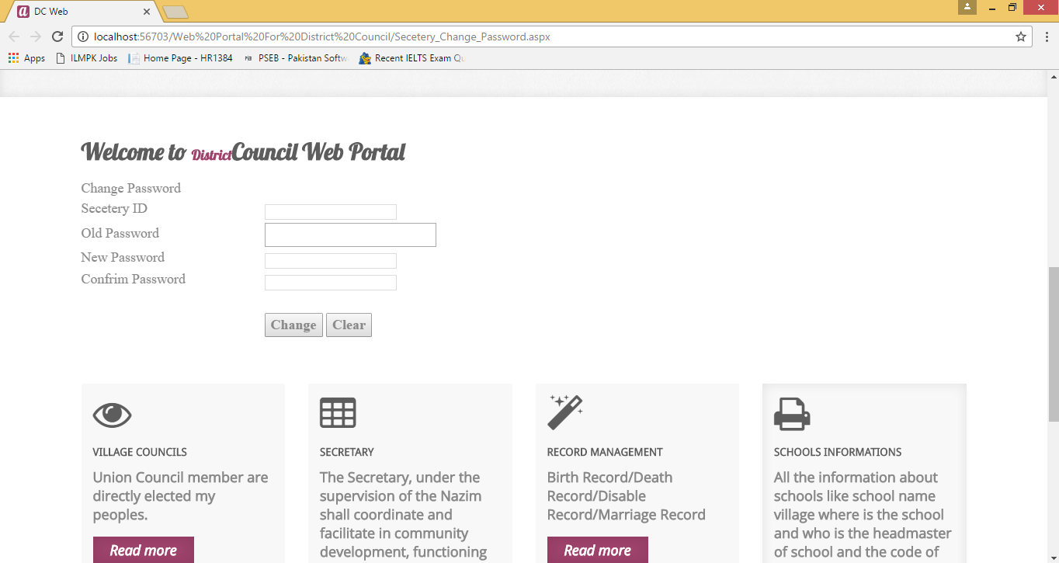

Figure 7.12 Change Sectary Password

## 7.13 Member Login

Higher Member can logon through this web form.

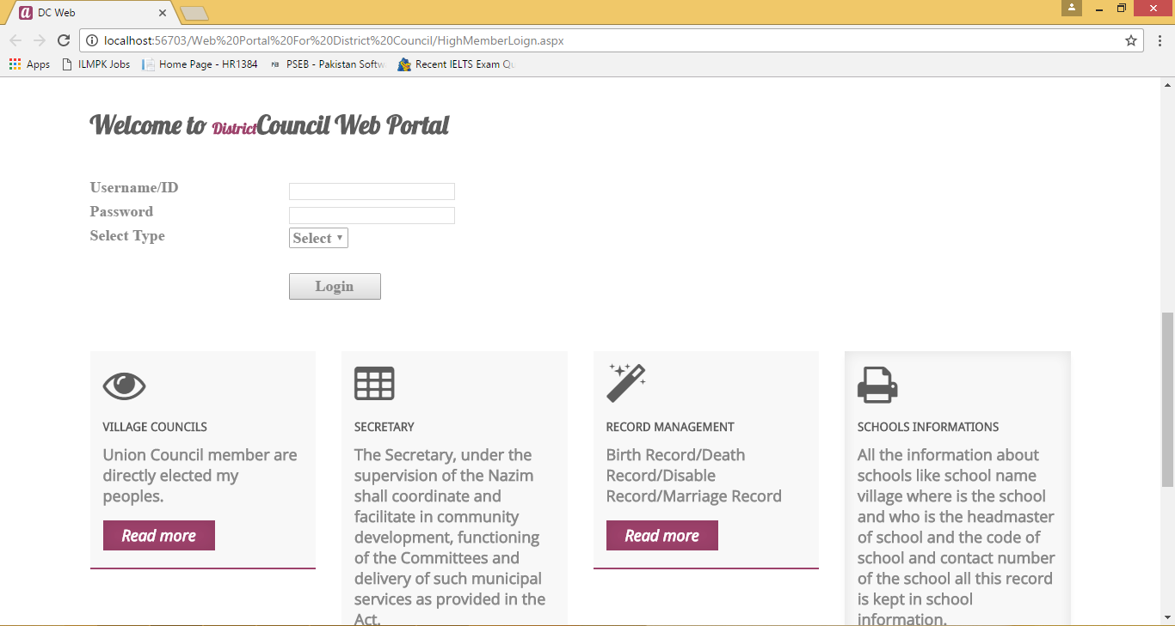

Figure 7.13 Member Login

# 

# References

* Beginning.CSS.3rd.Edition
* JavaScript Bible
* Jaffery A Hoffer, Mary B Prescott & Fred R McFadden - Modern Database Management (Eighth Edition).
* Kenneth E Kendall & Julie - System Analysis and Design.
* Rojer Pressman - Software Engineering
* Introduction to C# Complete Reference
* Software Engineering- A practitioner's Approach by Roger S. Pressman: 6th edition McGraw Hill, 2005
* An Integrated Approach to Software Engineering by Pankaj Jalote:3rd edition Springer, 2005
* Database Management System by IT Series.
* Web Development by IT Series.
* XML How To Program (Deitel)
* http://www.phpfree.com/
* http://www.hssrd.org/journal/spring2003/mansehra.htm
* <http://www.wikipedia.org>
* Jeffery A. Hoofer, Mary B Prescott & Fred R McFadden - Modern Database Management (Eighth Edition).
* Kenneth E Kendall & Julie - System Analysis and Design.
* Rogers Pressman - Software Engineering
* C# How to Program by Detail.
* Addison Wesley - Developing Applications with Visual Studio.
* Addison Wesley-A Developer’s guide to SQL Server 2005.
* IT Series A Fundamental Study of Database Management System.